Kingston Hydro Corporation
EB-2024-0037
October 1, 2024

Please note that Kingston Hydro Corporation (Kingston Hydro) is responsible for ensuring that all documents it files with the Ontario Energy Board (OEB), including responses to OEB staff questions and any other supporting documentation, do not include personal information (as that phrase is defined in the Freedom of Information and Protection of Privacy Act), unless filed in accordance with rule 9A of the OEB’s Rules of Practice and Procedure.

OEB Staff Question-1
Ref: 2025 IRM Rate Generator Model, Tabs 11, 15 and 20
On June 27, 2024, the OEB issued a Decision and Rate Order regarding 2024 Uniform Transmission Rates (UTRs). Any further updates will be reflected in the final Rate Generator Model.
OEB staff has updated Kingston Hydro’s Rate Generator Model with the 2024 UTRs for the 2025 year.
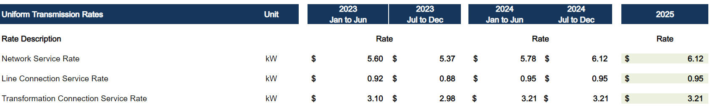
Question:
- Please confirm the accuracy of the Rate Generator Model following this update.

OEB Staff Question-2

Ref: 2025 IRM Rate Generator Model, Tab 3, Continuity Schedule

On July 26, 2024, the OEB published the 2024 Quarter 4 prescribed accounting interest rates applicable to the carrying charges of deferral, variance and construction work in progress (CWIP) accounts of natural gas utilities, electricity distributors and other rate-regulated entities.

Question:

- Please ensure Tab 3 (Continuity Schedule) is updated as necessary to reflect the Q4 2024 OEB-prescribed interest rate of 4.40%.

OEB Staff Question-3

Ref: Rate Generator Model, Tab 9, Shared Tax-Rate Rider

Applicants are required to input data from the last OEB-approved cost of service application in Tab 9 of the Rate Generator Model.

Question:
- Please complete the required fields in Tab 9 of the Rate Generator Model as shown below:
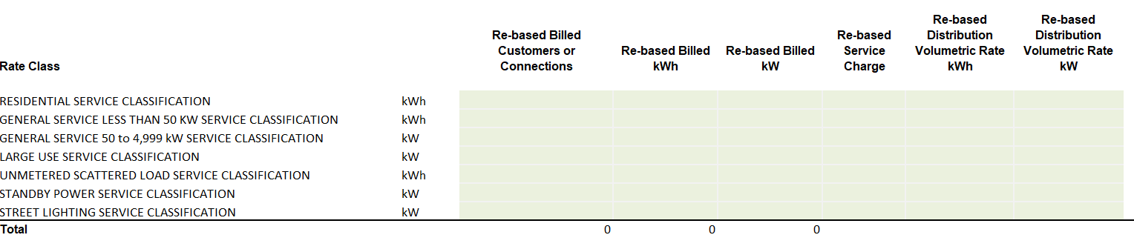

EB-2024-0183, Decision and Rate Order, June 27, 2024

