

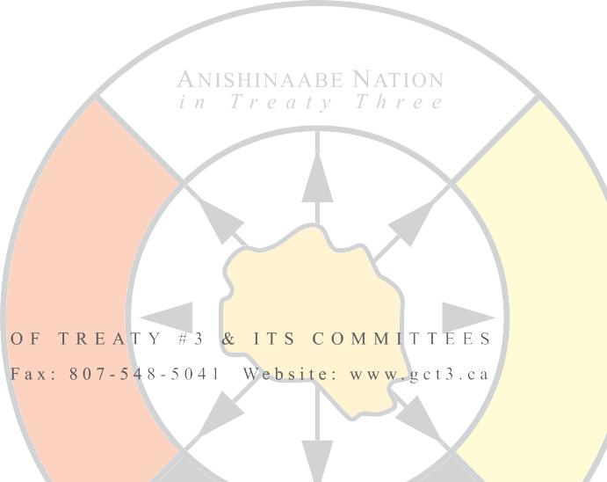

April 30, 2024

Ontario Energy Board

2300 Yonge Street, 27th floor

P.O. Box 2319

Toronto, ON M4P 1E4

# RE: Proposed revisions to the Indigenous consultation provisions of the Environmental Guidelines for the Location, Construction and Operation of Hydrocarbon Projects and Facilities in Ontario (EB-2024-0079) AND Questions related to participation in OEB hearings (EB-2022-0011)

Dear Ms. Nancy Marconi and Mr. Ritchie Murray,

The Territorial Planning Unit of Grand Council Treaty #3 has reviewed the proposed revisions to the Indigenous consultation provisions of the Environmental Guidelines for the Location, Construction and Operation of Hydrocarbon Projects and Facilities in Ontario (EB-2024-0079)and is providing the following comments.

**Background:** The comments below are representative of the Territorial Planning Unit (TPU) of Grand Council Treaty #3. Grand Council Treaty #3 is the Traditional Government of the Anishinaabe Nation of Treaty #3. Grand Council Treaty #3 represents 28 First Nations across the Territory. Grand Council's mandate is to protect the future of the Anishinaabe people by ensuring the protection, preservation, and enhancement of inherent and treaty rights. The TPU is a department within the Grand Council that works with the Treaty #3 Leadership to protect the lands, water, and resources within the 55,000 square miles of Treaty #3 Territory. The TPU is guided by Anishinaabe Inakonigaawin - Manito Aki Inakonigaawin (Great Earth Law) and Treaty #3 Nibi (water) Declaration.

**Governance:** Treaty #3 territory is governed by Anishinaabe law, called Manito Aki Inakonigaawin (Great Earth Law), and the Nibi declaration. Manito Aki Inakonigaawin represents respect, reciprocity, and responsibilities with all relations in regards to Mother Earth. The law signifies the duty to respect and protect lands affected by over-usage, degradation, and unethical processes. The law is unique to Treaty #3 territory and passed on through our elders and knowledge keepers.

The Nibi Declaration represents respect, love, and the sacred relationship with nibi (water) and the life that it brings. It is based on teachings about water, lands, other elements like air and wind, and creation. The declaration is meant to preserve and share knowledge with youth and future generations. The declaration guides us in our relationship with nibi so we can take action individually, in our communities, and as a nation to help ensure healthy, living nibi for all creation.

**Comments on the Indigenous consultation provisions of the Environmental Guidelines for the Location, Construction and Operation of Hydrocarbon Projects and Facilities in Ontario (EB-2024-0079):**

* First Nations must be able to trigger the Crown’s Duty to Consult at the early stages of a project’s development. Having to request intervenor status after an application for OEB leave to construct has been submitted disadvantages a First Nation compared to those that the Government selected to be consulted at the outset of a project. For Treaty #3, we ask that the Ministry of Energy notifies the Territorial Planning Unit of Grand Council Treaty #3 of all projects on which Treaty #3 First Nations are mandated to be consulted, and to provide us with the list of consulted First Nations. This would allow us to notify other First Nations and, if applicable, request a change to the list.
* The guidelines should state that each Consultation Report must demonstrate **meaningful** Indigenous consultation, in line with Section 35 of Canada's Constitution Act, 1982 and applicable case law.
* For First Nations to meaningfully participate, consultation must accommodate their specific needs and protocols. We ask that any organization enacting the Crown's Duty to Consult (i.e. the Ministry of Energy, the Ontario Energy Board, or a Proponent) negotiates a consultation plan with each consulted First Nation to enable meaningful participation.
* Following your clarification from April 18, 2024, we understand that the OEB does not specify when it considers consultations to be meaningfully and substantially accomplished, nor when it would accept a proponent’s efforts to reach out to First Nations, due to ever evolving case law. This practice, however, obscures how the OEB makes its case-by-case determinations. For more transparency, we suggest that the OEB publishes its guidelines on these matters, and updates them with the evolving case law.
* The filing procedure in Appendix E is very cumbersome, particularly the request to follow a specific naming convention and document submission standards, the use of RESS, and the process to request Cost Awards. To accommodate First Nations, First Nation Organizations, and intervenors, we ask that comments and cost claims may be submitted to the OEB in any form.
* Manito Aki Inakonigaawin requires not only consultation, but authorization (conditional consent) from the Anishinaabe Nation in Treaty #3 for any project to be implemented in Treaty #3 Territory.

**Questions related to participation in OEB hearings (EB-2022-0011)**

We also respond to your questions related to participation in OEB hearings (EB-2022-0011):

1. **Have you ever participated in an OEB hearing?** Response: Not that we are aware of, at least not during the tenure of any of our current staff.
2. **Can you identify the elements of the OEB’s hearing process that worked well?** Response: Not applicable
3. **What are elements of the OEB’s hearing process that you think could use improvement?** Response: Not applicable
4. **Is there other information that would help you to decide whether to participate in a hearing?** Response:

Capacity funding to meaningfully participate in hearing, succinct briefing on the subject matter, explanation of how input received in hearing will be considered, accommodations for First Nations

1. **Are there changes that you would suggest to better facilitate participation by Indigenous groups in OEB hearings?** Response: Similarly, as outlined in our first comment above, Indigenous groups should be engaged and consulted before a project even reaches the stage of an OEB hearing. That way, Indigenous groups have more time to prepare and become familiar with the process and any proposed project. Second, for us to participate, we must be aware of any OEB hearings happening. At the least, they should be posted on the Environmental Registry of Ontario, and we need to be notified directly if any hearing concerns proposals concerning Treaty #3 Territory. Third, any ways in which the OEB hearing process can be simplified, is welcome. Many Indigenous organizations do not have the capacity to learn how to navigate a very foreign process. We appreciate the idea of having a contact person at the OEB (see next question), but ideally the process could be reformed under the perspective of accessibility. Being confronted with a wide range of bureaucratic procedures (filing conventions and guidelines, submission forms etc.) can make us not want to engage, especially when we have other responsibilities in front of us. If these procedures are necessary, it would be helpful to have administrative staff at the OEB available that can help with filing all submissions in the appropriate way. That would be much more efficient than asking us to learn these procedures when we only engage with them every few years.
2. **Would it assist you if there was an identified person or group within the OEB that you could contact regarding a specific hearing or the hearing process more broadly.** Response: Yes, because navigating the process of an OEB hearing is very foreign for someone who does not regularly work with the OEB or similar hearings. Having a person at the OEB who could explain the process in plain language, before, during, and after a hearing, would be very helpful, if the process itself cannot be simplified in a way that such guidance would not be necessary.
3. **Are there other matters that you think the OEB should consider when examining how it engages with Indigenous communities in its hearings?**

The OEB needs to engage First Nations as Indigenous rightsholders, not simply stakeholders. This is why the intervenor process is not an appropriate avenue for Indigenous engagement and implementation of the Crown’s Duty to Consult. The OEB should also consider the Duty to Accommodate and create forms of engagement and hearings that are culturally appropriate.

If you require further information, please reach out to us.

Miigwetch,

Johann Strube

Johann Strube

Policy Analyst, Territorial Planning Unit

Grand Council Treaty #3

[johann.strube@treaty3.ca](mailto:johann.strube@treaty3.ca)



807-548-4214 ext.506