March 8, 2024

Ms. Nancy Marconi, Registrar

Ontario Energy Board

P.O. Box 2319

2300 Yonge Street, Suite 2700

Toronto, ON M4P 1E4

**Re: Tillsonburg Hydro Inc. EB-2023-0053**

Dear Ms. Marconi,

I am writing to you on behalf of Tillsonburg Hydro Inc. (THI) with respect to its planned 2024 rate application.  While it remains THI’s intent to file a cost of service application for the 2024 test year, due to resource shortages it has been challenging to complete the application. In order to proceed we expect that the application will not be filed until only shortly before April 30, 2024, the date on which THI’s new rates would in the normal course be implemented and effective.

Accordingly THI respectfully asks that THI’s distribution rates be made interim effective May 1, 2024 in order to preserve the ability of the Ontario Energy Board (the “OEB”) to choose an appropriate effective date for THI’s new rates once determined.   It is THI’s understanding that an order making its rates interim effective May 1, 2024 would be without prejudice to the positions of any parties that the OEB approves as participants in the rate proceeding with respect to an appropriate effective date for any new distribution rates that the OEB may approve, including consideration of THI’s late filing of the application.

Please contact the undersigned if there are any questions with respect to our request.

Yours truly,

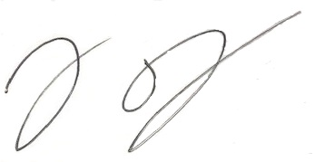

Graig Pettit

General Manager

Tillsonburg Hydro Inc.