Entegrus Powerlines Inc.
EB-2023-0016
October 3, 2023
Please note, Entegrus Powerlines Inc. (Entegrus) is responsible for ensuring that all documents it files with the OEB, including responses to OEB staff questions and any other supporting documentation, do not include personal information as that phrase is defined in the Freedom of Information and Protection of Privacy Act, unless filed in accordance with rule 9A of the OEB’s Rules of Practice and Procedure.

Staff Question-1
Ref: Rate Generator Model, Tab 3, Continuity Schedule (Main and St. Thomas Rate Zones)
On September 12, 2023, the OEB published the 2023 Quarter 4 prescribed accounting interest rates applicable to the carrying charges of deferral, variance and construction work in progress (CWIP) accounts of natural gas utilities, electricity distributors and other rate-regulated entities.

Question:

- Please update Tab 3 (Continuity Schedule) as necessary to reflect the Q4 2023 OEB-prescribed interest rate of 5.49%.

Staff Question-2
Ref 1: IRM Rate Generator Model, Tab 3, Continuity Schedule (Main and St. Thomas Rate Zones)
Ref 2: IRM Rate Generator – DVA Tabs Instructions (Main and St. Thomas Rate Zones)
Ref 3: OEB Guidance for Electricity Distributors with Forgone Revenues Due to
Postponed Rate Implementation from COVID-19, August 6, 2020, page 5
On July 18, 2023, the OEB issued the DVA Tabs Instructions for the 2024 IRM Rate Generator Model. Pages 1 and 3 noted that Account 1509 - Impacts Arising from the COVID-19 Emergency, Subaccount Forgone Revenues from Postponing Rate Implementation was added to the model. A separate rider is calculated for this account in Tab 7, if the disposition is approved.

Regarding Account 1509, Impacts Arising from the COVID-19 Emergency Account, Subaccount Forgone Revenues from Postponing Rate Implementation, the following steps are noted in the August 6, 2020 guidance:

- Upon implementation of the forgone revenue rate rider that is calculated from the Forgone Revenue Model, the rate rider transactions will be recorded in the same Forgone Revenues Subaccount. This will draw down the accumulated balance of actual forgone revenues/amounts.

- Any residual balance after the expiry of the rate riders should be requested for final disposition in a future rate application (cost of service or IRM), once the balance has been audited in accordance with normal deferral and variance account disposition practices.

- If disposition is approved, the residual balance in the Forgone Revenues Subaccount should be disposed proportionately by customer class and the residual balance will be transferred to Account 1595.

Questions:

- Please update Tab 3 (Continuity Schedule) as necessary to reflect a balance in Account 1509 – Impacts Arising from the COVID-19 Emergency, Subaccount Forgone Revenues from Postponing Rate Implementation. Please complete the above-noted steps #1, #2, #3.
- If this balance is not applicable, please explain.

Staff Question-3
Ref 1: 2024 IRM Rate Generator Model, Tabs 11, 15 and 20
Ref 2: OEB Letter, EB-2023-0222, 2024 Preliminary Uniform Transmission Rates and Hydro One Sub-Transmission Rates, September 28, 2023

On September 28, 2023 the OEB issued a letter regarding 2024 Preliminary Uniform Transmission Rates (UTRs) and Hydro One Sub-Transmission Rates. The OEB determined the use of preliminary UTRs to calculate 2024 Retail Service Transmission Rates (RTSRs) to improve regulatory efficiency, allowing for this data to feed into the rate applications including annual updates for electricity distributors on a timelier basis. The OEB also directed distributors to update their 2024 application with Hydro One Network Inc.’s proposed host RTSRs.
OEB staff has updated Entegrus’ Rate Generators with the preliminary UTRs and proposed host RTSR by HONI as follows:
UTRs:
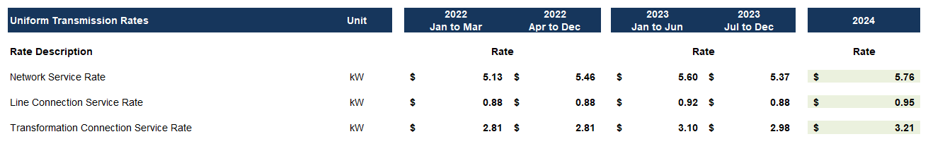
Hydro One Sub-Transmission Rates:
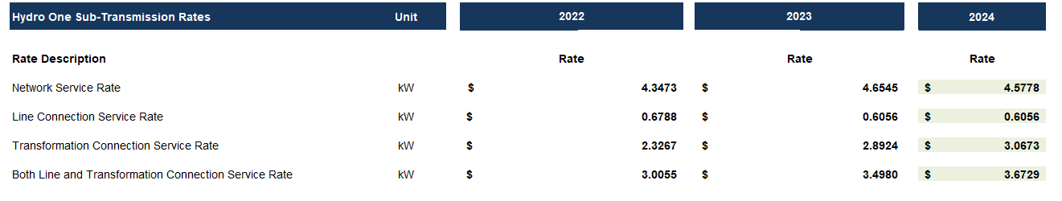
Question:

- Please confirm the accuracy of the Rate Generator update, as well as the accuracy of the resulting Retail Transmission Service Rates following these updates.

Staff Question-4
Ref: GA Workform, Principal Adjustments Tab (Main Rate Zone)

The principal adjustments relating to CT 148 are expected to be equal and offsetting between Account 1589 – RSVA Global Adjustment and Account 1588 – RSVA Power.

Question:

- Please confirm the submitted values and if applicable, explain the variance.

Staff Question-5
Ref 1: Manager’s Summary section 6.3.8 and 6.3.9 (Main Rate Zone)
Ref 2: Rate Generator Model, Tabs 6 and 6.1a (Main Rate Zone)
Ref 3: Manager’s Summary section 7.3.8 and 7.3.9 (St. Thomas Rate Zone)
Ref 4: Rate Generator Model, Tabs 6 and 6.1.a (St. Thomas Rate Zone)

The Manager’s Summary and Rate Generator Models contain conflicting references to the number of transitional customers during 2022. For the Main Rate Zone, there are references to 6 and 12 transitional customers. For the St. Thomas Rate Zone, there are references to 2 and 3 transitional customers.

Question:

- For the record, please confirm there were 6 transitional customers for the Main Rate Zone, and 2 transitional customers for the St. Thomas Rate Zone during 2022.

Staff Question-6
Ref 1: Manager’s Summary, section 6.3.7 (Main Rate Zone)
Ref 2: Manager’s Summary, section 7.3.7 (St. Thomas Rate Zone)
Ref 3: IndEco Report, page 12
Ref 4: 2024 LRAMVA Workform
Ref 5: Rate Generator Model, Tab 19, Additional Rates (Main and St. Thomas
Rate Zones)
Ref 6: Guidance on Prospective LRAM Amounts – 2024 Rates

Entegrus is applying for prospective LRAM-eligible amounts for the Main and St. Thomas Rate Zones. The IndEco Report indicates that the prospective balances will be adjusted to current year dollars and claimed in the rate application for the respective years.

As per the Guidance on Prospective LRAM Amounts, distributors should propose rate riders to recover each annual LRAM-eligible amount in the corresponding rate year, beginning with the application for 2024 rates, and continuing each rate year until all amounts shown in Table 1- C of the LRAMVA Workform have been recovered.

Questions:

- For the prospective disposition, please explain why Entegrus has not proposed rate riders to recover each annual LRAM-eligible amount in the corresponding rate year, beginning with 2024, and continuing each rate year until all amounts shown in Table 1- C have been recovered.
- If prospective disposition is being sought, please provide the calculation of the resulting rate riders for the Main and St. Thomas Rate Zones.
- Please input those riders into Tab 19 of the IRM Rate Generator Models for the Main and St. Thomas Rate Zones.

