Jun 30, 2023

Ontario Energy Board

P.O. Box 2319

2300 Yonge Street

27th Floor

Toronto, ON M4P 1E4

**Re: ULO Implementation (EB 2022-0160): Welland Hydro-Electric System Corp.**

Welland Hydro-Electric System Corp. has adapted its systems and processes to enable it to comply with the amendments to the SSSC that came into force on January 1, 2023. Welland Hydro RPP consumers can elect to be charged on the basis of the new ultra-low overnight (ULO) price plan as of July 1, 2023.

Sincerely,

**WELLAND HYDRO-ELECTRIC SYSTEM CORP.**

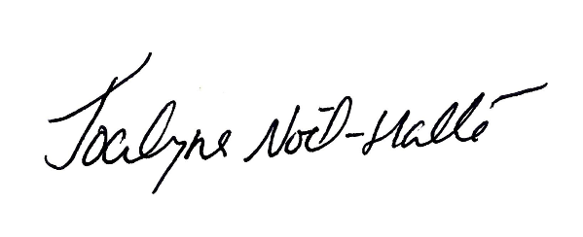

Jocelyne Noël-Hallé

Billing Administrator