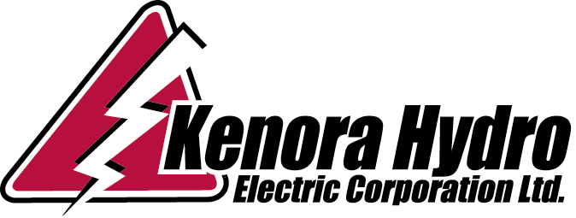

Ontario Energy Board February 28, 2015
P.O. Box 2319
27th Floor
2300 Yonge Street
TORONTO, ON M4P 1E4

Attention: Mr. Antonopoulos

Re: Kenora Hydro - May 1, 2016 Rate Filing

Dear Mr. Antonopoulos:

Please accept this letter as acknowledgement that Kenora Hydro will be filing an Annual Incentive Rate Setting Index Model for rates effective May 1, 2016. Kenora Hydro will not be submitting a COS filing for 2016 rates.

Kenora Hydro was within the +-300 basis point dead band for both the 2012 and 2013 years, and anticipates that financial results will be similar in 2014 and 2015.

Deferring rate rebasing is not seen as having any significant impact on the financial position of Kenora Hydro.

Please contact me directly at 807-467-2014, or Dave Sinclair at 807-467-2075 should you require additional information.

Sincerely,

Janice Robertson, CPA, CA
Manager of Finance & Regulatory Affairs
Kenora Hydro Electric Corporation Ltd.
Ph (807) 467-2014
Fax (807) 467-2068
jrobertson@kenora.ca

Box 2680-215 Mellick Avenue, Kenora, Ontario P9N 3X8 Phone (807) 467-2075 Fax (807) 467-2068

