

Conservation and Demand Management
2013 Annual Report

Submitted to:
Ontario Energy Board

Submitted on September 30, 2014
TABLE OF CONTENTS
Please use the hyperlink function in the Table of Contents as per OEB staff
Executive Summary 1
Background 2
1 Board-Approved CDM Program 3
1.1 Introduction 3
1.2 TOU Pricing 3
1.2.1 Background 3
1.2.2 TOU PROGRAM DESCRIPTION 3
1.3 Hearst Power’s Application with the OEB 4
1.4 Hearst Power’s Application with the OPA’s Conservation Fund 4
2 OPA-Contracted Province-Wide CDM Programs 6
2.1 Introduction 6
2.2 Program Descriptions 8
2.2.1 Residential Program 8
2.2.2 Commercial and Institutional Program 14
2.2.3 Industrial Program 18
2.2.4 Low Income Initiative (Home Assistance Program) (Schedule E-1) 22
2.2.5 Pre-2011 Programs 22
3 2013 LDC CDM Results 23
3.1 Participation and Savings 23
3.2 Evaluation 26
3.3 Spending 27
3.4 Additional Comments 30
4 Combined CDM Reporting Elements 31
4.1 Progress Towards CDM Targets 31
4.2 Variance from Strategy 32
4.3 Outlook to 2014 and Strategy Modifications 32
5 Conclusion 34
Appendix A: Initiative Descriptions 35
Appendix B: Pre-2011 Programs 47

Executive Summary

This annual report is submitted by Hearst Power Distribution Company Limited (“Hearst Power”) in accordance with the filing requirements set out in the CDM Code (Board File No. EB-2010-0215), specifically Appendix C Annual Report Template, as a progress report and modification to Hearst Power Strategy. Accordingly, this report outlines Hearst Power CDM activities for the period of January 1, 2013 to December 31, 2013. It includes net peak demand and net energy savings achieved from 2011, 2012 and 2013, with discussion of the current/future CDM framework, CDM program activities, successes and challenges, as well as forecasted savings to the end of 2014.
Hearst Power did not apply for any Board-Approved CDM Programs during 2013; however, as noted in the CDM guidelines, released April 26, 2012, the Ontario Energy Board (OEB) has deemed Time-of-Use (TOU) pricing a Province-wide Board-Approved CDM Program. The Ontario Power Authority (OPA) is to provide measurement and verification on TOU. At the time of this report the OPA has not released any verified results of TOU savings to Hearst Power.
In 2011, Hearst Power contracted with the Ontario Power Authority (OPA) to deliver a portfolio of OPA-Contracted Province-Wide CDM Programs to all customer segments including residential, commercial, institutional, industrial and low income. These programs were rolled-out by the OPA in June 2011. In 2011 Program activities were centered on building a foundation for full program execution over the next three years of the program term, including staffing, procurement, and program delivery.
In 2012, Hearst Power was active in promoting CDM programs. Mailing, telephone and visitation campaigns were run to promote business and industrial programs. Burman Energy was under contract throughout the year to administer CDM programs on Chapleau PUCs behalf.
In 2013, Hearst Power continued awareness efforts in all program areas in efforts to maintain momentum and participation of the saveONenergy programs. Newspaper Ads were used to promote residential programs such as the annual coupons and one on one meetings were held with key local businesses in order to promote the commercial programs. The Home Assistance Program was also implemented in 2013 garnering much success in the low-income area.
To date Hearst Power has achieved 0.18 MW of net incremental peak demand savings and 1.922 GWh of net incremental energy savings in 2013. A summary of the achievements towards the CDM targets is shown below:
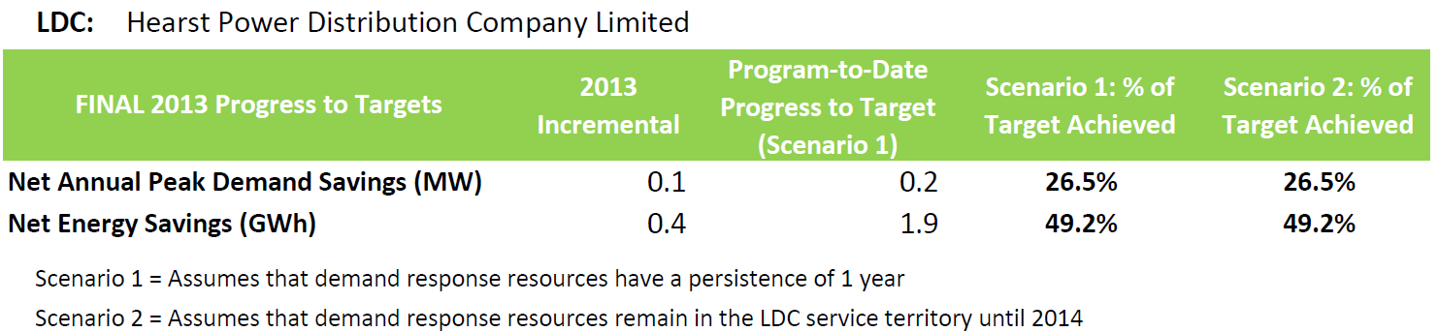

The updated forecast prepared for this report shows that there will be a shortfall of approximately 0.33 MW versus Hearst Power’s 2014 peak demand reduction target. In addition to the peak demand savings being below target, Hearst Power also expects a shortage of 1.3 GWh of the energy savings target. Given the expected shortfall, Hearst Power continues to work actively on participant engagement. In addition Hearst Power has partnered with other LDCs, and has been working with the Ontario Power Authority (“OPA”) and the Electrical Distribution Association (“EDA”) to improve program effectiveness, however it is Hearst Power’s position that in itself will not fully overcome the forecasted peak demand savings shortfall.
Background

On March 31, 2010, the Minister of Energy and Infrastructure of Ontario, under the guidance of sections 27.1 and 27.2 of the Ontario Energy Board Act, 1998, directed the Ontario Energy Board (OEB) to establish Conservation and Demand Management (CDM) targets to be met by electricity distributors. Accordingly, on November 12, 2010, the OEB amended the distribution license of Hearst Power to require Hearst Power, as a condition of its license, to achieve 3.91. GWh of energy savings and 0.68 MW of summer peak demand savings, over the period beginning January 1, 2011 through December 31, 2014.
In accordance with the same Minister’s directive, the OEB issued the Conservation and Demand Management Code for Electricity Distributors (the Code) on September 16, 2010. The code sets out the obligations and requirements with which electricity distributors must comply in relation to the CDM targets set out in their licenses. To comply with the Code requirements, Hearst Power submitted its CDM Strategy on November 12, 2010 which provided a high level of description of how Hearst Power intended to achieve its CDM targets.
The Code also requires a distributor to file annual reports with the Board. This is the third Annual Report by Hearst Power and has been prepared in accordance with the Code requirement and covers the period from January 1, 2013 to December 31, 2013.
Hearst Power submitted its 2011 Annual Report on September 30, 2011 which summarized the CDM activities, successes and challenges experienced by Hearst Power for the January 1, 2011 to December 31, 2011 period. The OEB’s 2011 CDM Results report identified that the delay in the full suite of CDM Programs being made available by the OPA, and the absence of some programs negatively impacted the final 2011 results for the LDCs. This issue was also highlighted in Volumes I & II of the Environmental Commissioner’s Report on Ontario’s Annual Energy Conservation Progress.
On December 21, 2012, the Minister of Energy directed the Ontario Power Authority (OPA) to fund CDM programs which meet the definition and criteria for OPA-Contracted Province-Wide CDM Programs for an additional one-year period from January 1, 2015 to December 31, 2015.
The Ministerial Directive did not amend the timelines for LDCs to achieve their energy savings and demand savings targets. Therefore, the main focus of the LDCs remains the achievement of CDM targets by December 31, 2014.
Hearst Power submitted its 2012 Annual Report on September 30, 2012 which summarized the CDM activities undertaken by Hearst Power for the January 1, 2012 to December 31, 2012 period. The OEB’s 2012 CDM Results report identified that the majority of LDCs achieved close to 20% of their net peak demand (MW) target from their 2012 results. However, LDCs generally advised the Board that meeting their peak demand (MW) target is not likely and that a shortfall is expected.
LDCs collectively achieved approximately 8% of the energy savings (GWh) target, which is slightly below the 10% incremental annual savings needed each year to achieve the energy savings target. Overall the cumulative results represent approximately 65% of the net energy target of 6,000 GWh.
The report identified that although there have been improvements to programs there still remains some shortcoming to the design and delivery of certain initiatives that have resulted in a negative impact to some programs. In particular, the change management process still requires improvements to expedite enhancements to initiatives. The report also noted that certain initiatives may be reaching the point of market saturation and that new initiatives may need to be developed in order to take the place of the existing initiatives.

Board-Approved CDM Program

Hearst Power did not apply for any Board Approved CDM Programs in 2013.

Introduction
In its Decision and Order dated November 12 2010 (EB-2010-0215 & EB-2010-0216), the OEB ordered that, (to meet its mandatory CDM targets), “Each licensed electricity distributor must, as a condition of its license, deliver Board-Approved CDM Programs, OPA-Contracted Province-Wide CDM Programs, or a combination of the two”.
At this time, the implementation of Time-of-Use (“TOU”) Pricing has been deemed as a Board-Approved Conservation and Demand Management (“CDM”) program that is being offered in Hearst Power’s service area.

TOU Pricing

Background
In its April 26, 2012 CDM Guidelines, the OEB recognizes that a portion of the aggregate electricity demand target was intended to be attributable to savings achieved through the implementation of TOU Pricing. The OEB establishes TOU prices and has made the implementation of this pricing mechanism mandatory for distributors. On this basis, the OEB has determined that distributors will not have to file a Board-Approved CDM program application regarding TOU pricing. The OEB has deemed the implementation of TOU pricing to be a Board-Approved CDM program for the purposes of achieving the CDM targets. The costs associated with the implementation of TOU pricing are recoverable through distribution rates, and not through the Global Adjustment Mechanism (“GAM”).
In accordance with a Directive dated March 31, 2010 by the Minister of Energy and Infrastructure, the OEB is of the view that any evaluations of savings from TOU pricing should be conducted by the OPA for the province, and then allocated to distributors. Hearst Power will report these results upon receipt from the OPA.
The OPA had retained The Brattle Group as the evaluation contractor and has been working with an expert panel convened to provide ongoing advice on methodology, data collection, models, savings allocation, etc. The initial evaluations were conducted in 2013 with five LDCs – Hydro One, THESL, Ottawa Hydro, Thunder Bay and Newmarket. Preliminary results from these five LDCs were issued to the five LDCs involved in the study in August 2013 and are now publically available on the OPA website. Preliminary results demonstrated load shifting behaviours from the residential customer class.
Three additional LDCs were added to the study in 2014 – Cambridge-North Dumfries, Powerstream and Sudbury. Preliminary results from this study are planned to be issued to the eight LDCs in September 2014. The OPA advised that the TOU study will be complete in the summer of 2015 and final verified savings will be available for LDCs to include in the 2014 Annual Report.
As of September 30, 2014, the OPA has not released any verified results of TOU savings to Hearst Power. Therefore Hearst Power is not able to provide any verified savings related to LDC’s TOU program at this time.

TOU PROGRAM DESCRIPTION

Target Customer Type(s): Residential and small business customers (up to 250,000 kWh per year)
Initiative Frequency: Year-Round
Objectives: TOU pricing is designed to incent the shifting of energy usage. Therefore peak demand reductions are expected, and energy conservation benefits may also be realized.
Description: In August of 2010, the OEB issued a final determination to mandate TOU pricing for Regulated Price Plan (“RPP”) customers by June 2011, in order to support the Government’s expectation for 3.6 million RPP consumers to be on TOU pricing by June 2011, and to ensure that smart meters funded at ratepayer expense are being used for their intended purpose.
The RPP TOU price is adjusted twice annually by the OEB. A summary of the RPP TOU pricing is provided below:
RPP TOU |  | Rates (cents/kWh)
Effective Date | On Peak | Mid Peak | Off Peak
November 1, 2010 | 9.9 | 8.1 | 5.1
May 1, 2011 | 10.7 | 8.9 | 5.9
November 1, 2011 | 10.8 | 9.2 | 6.2
May 1, 2012 | 11.7 | 10.0 | 6.5
November 1, 2012 | 11.8 | 9.9 | 6.3
May 1, 2013 | 12.4 | 10.4 | 6.7
November 1, 2013 | 12.9 | 10.9 | 7.2
May 1, 2014 | 13.5 | 11.2 | 7.5

Delivery: The OEB set the rates; LDCs install and maintain the smart meters and convert customers to TOU billing.
Initiative Activities/Progress:
Hearst Power Distribution Co. Ltd. began transitioning its RPP customers to TOU billing on September 1st, 2011. At December 31st, 2013, 2604 (99%) RPP customers were on TOU billing.

Hearst Power’s Application with the OEB
Hearst Power did not submit a CDM program application to the OEB in 2013.

Hearst Power’s Application with the OPA’s Conservation Fund
In 2013, the OPA introduced the Conservation Fund to help meet LDC’s interest in the development and launch of new local, regional and province-wide initiatives. The Conservation Fund’s LDC Program Innovation Stream fast-tracks LDC-led program design and the launch of successfully piloted initiatives prior to full scale deployment. By driving program innovation through the Conservation Fund, LDCs have the opportunity to both realize additional savings through the piloting and implementation of initiatives not currently addressed by the OPA portfolio and the means to test concepts for future local or province wide programs post 2014. As per the OPA, as of March 2014, three pilots have been contracted and are underway with Toronto Hydro and Niagara Peninsula Energy and ten others are in various stages of the contracting and development process.
In addition, building on LDC interest in social benchmarking services for the residential sector, in 2013 the Conservation Fund in collaboration with Hydro One, Milton Hydro and Horizon Utilities completed the procurement of three social benchmarking pilot projects. Beginning in 2014 these services will be offered to more than 100,000 customers for a one year period, with evaluation reports published shortly thereafter.
Hearst Power did not submit a CDM program application to the OPA’s Conservation Fund in 2013.

OPA-Contracted Province-Wide CDM Programs

Introduction

Effective May 9, 2011, Hearst Power entered into an agreement with the OPA to deliver CDM programs extending from January 1, 2011 to December 31, 2014, which are listed below. Program details are included in Appendix A. In addition, results include projects started pre 2011 which were completed in 2011:
Initiative | Schedule | Date schedule posted | In Market Date
Residential Programs
Appliance Retirement | Schedule B-1, Exhibit D | Jan 26,2011 | March 1, 2011
Appliance Exchange | Schedule B-1, Exhibit E | Jan 26, 2011 | March 1, 2011
HVAC Incentives | Schedule B-1, Exhibit B | Jan 26, 2011 | March 1, 2011
Conservation Instant Coupon Booklet | Schedule B-1, Exhibit A | Jan 26, 2011 | March 1, 2011
Bi-Annual Retailer Event | Schedule B-1, Exhibit C | Jan 26, 2011 | March 1, 2011
Retailer Co-op | n/a | n/a
Residential Demand Response | Schedule B-3 | Aug 22, 2011 | Not in market
New Construction Program | Schedule B-2 | Jan 26, 2011 | March 1, 2011
Home Assistance Program | Schedule E-1 | May 9, 2011 | January 1, 2013
Commercial & Institutional Programs
Efficiency: Equipment Replacement | Schedule C-2 | Jan 26, 2011 | March 1, 2011
Direct Install Lighting  - General Service <50 kW | Schedule C-3 | Jan 26, 2011 | March 1, 2011
Existing Building Commissioning Incentive | Schedule C-6 | Feb 2011 | March 1, 2011
New Construction and Major Renovation Initiative | Schedule C-4 | Feb 2011 | March 1, 2011
Energy Audit | Schedule C-1 | Jan 26, 2011 | March 1, 2011
Commercial Demand Response  - General Service <50 kW | Schedule B-3 | Jan 26, 2011 | March 1, 2011
Industrial Programs - General Service 50 kW & above
Process & System Upgrades | Schedule D-1 | May 31, 2011 | March 1, 2011
Monitoring & Targeting | Schedule D-2 | May 31, 2011 | March 1, 2011
Energy Manager | Schedule D-3 | May 31, 2011 | March 1, 2011
Key Account Manager (“KAM”) | Schedule D-4 | May 31,2011 | March 1, 2011
Efficiency Equipment Replacement Incentive  - (part of the C&I program schedule) | Schedule C-2 | May 31, 2011 | March 1, 2011
Demand Response 3 | Schedule D-6 | May 31, 2011 | March 1, 2011

In addition, results were realized towards LDC’s 2011-2014 target through the following pre-2011 programs:
- Electricity Retrofit Incentive Program
- High Performance New Construction
- Toronto Comprehensive
- Multifamily Energy Efficiency Rebates
- Data Centre Incentive Program
- EnWin Green Suites

As per the table below, several program initiatives are no longer available to customer or have not been launched in 2013.
Not in Market | Objective | Status
Residential Program
Midstream Electronics | Encourages retailers to promote and sell high efficency televisions, and for distributors to distribute high efficiency set top boxes. | Did not launch and removed from Schedule in Q2, 2013.
Midstream Pool Equipment | Encourage pool installers to sell and install efficient pool pump equipment in residential in-ground pools. | Did not launch and removed from Schedule in Q2, 2013.
Home Energy Audit Tool | This is a provincial online audit tool to engage customers in conservation and help drive customer participation to CDM programs. | Did not launch and removed from Schedule in Q2, 2013.
Commercial & Institutional Program
Direct Service Space Cooling | Offers free servicing of air conditioning systems and refrigeration units for the purpose of achieving energy savings and demand reduction. | Did not launch in 2011/2012. As per the OPA there no plans to launch this Initiative in 2013.
Demand Response 1 (“DR1”) | This initiative allows distribution customers to voluntarily reduce electricity demand during certain periods of the year pursuant to the DR 1 contract. The initiative provides DR payment for service for the actual electricity reduction provided during a demand response event. | No customer uptake for this initiative. As a result this Initiative was removed from the Schedule in Q4, 2012.
Industrial Program
DR1 | As above | No customer uptake for this initiative. Removed in Q4, 2012.

The Master CDM Program Agreement includes program change management provision in Article 3. Collaboration between the OPA and the Local Distribution Companies (LDCs) commenced in 2011, and continued in 2012, as the change management process was implemented to enhance the saveONenergy program suite. The change management process allows for modifications to the Master Service Agreement and initiative Schedules. The program enhancements give LDCs additional tools and greater flexibility to deliver programs in a way that meets the needs of customers and further drives participation in the Initiatives.

Program Descriptions

Full OPA-Contracted Province-Wide CDM Program descriptions are available on the OPA’s website at http://www.powerauthority.on.ca/ldc-province-wide-program-documents and additional initiative information can be found on the saveONenergy website at https://saveonenergy.ca. The targeted customer types, objectives, and individual descriptions for each Program Initiative are detailed in Appendix A.

RESIDENTIAL PROGRAM

Description: Provides residential customers with programs and tools to help them understand and manage the amount of energy they use throughout their entire home and help the environment.
Objective: To provide incentives to both existing homeowners and developers/builders to motivate the installation of energy efficiency measures in both existing and new home construction.
Discussion:
The addition of LED measures to the Bi-Annual Retailer Event and in the Annual Coupon initiative in July 2013 has had a positive impact on customer participation. There was the added benefit of three LDC custom coded coupon options for LDCs to utilize in 2013. The Residential Demand Response program continues to be the largest contributor to demand savings in the Residential Program and has been generally well received by consumers. Unfortunately, there were no savings associated with the Energy Display attributed to LDCs in the OPA’s 2012 verified results.
The Residential Program Portfolio is predominately a carryover of Initiatives from previous programs. It is mostly driven by retailers and contractors who many not have fully delivered what was anticipated. Three new initiatives (Midstream Electronics, Midstream Pool Equipment and Home Energy Audit Tool) were not launched and subsequently removed from the schedule in 2013 with no new additions. Delays in communication with regards to Initiative offerings and results reporting have hampered LDCs abilities to engage customers and promote participation.
Province-wide advertising was re-introduced in Q3 2013. This provided limited value due to the late market entry, especially for peaksaverPLUS.
Work to revitalize and increase the effectiveness and breadth of the Initiatives through the Residential Program continue to be a high priority. Opportunities within the Residential marketplace need to be identified, developed and offered to customers. The Version 5 Schedule changes implemented in Q1/Q2 2014 have increased the number of LDC coded coupons available and added new installations to the Heating and Cooling Incentive.

Appliance Retirement Initiative (Exhibit D)

Initiative Activities/Progress:
For Hearst Power, there was only one old appliances removed from service in 2013, representing a net energy savings of 417 kWh for the year. The cumulative energy savings for this initiative were verified at 38,406 kWh. New initiatives will be needed to encourage further homeowner savings in the appliance category.
Marketing activities for this program included brochures at the office which outlined various residential programs.
Additional Comments:
- Due to the duration of the program, and the revised eligibility requirements to a minimum of 20 years old, this Initiative appears to have reached market saturation and has been under consideration for removal from the Portfolio.
- Rather than strictly remove this Initiative from the schedules, the OPA and LDCs could review what opportunities there are to include other measures such as stoves, dishwashers, washers and dryers. The framework of this Initiative may be a suitable foundation for a more holistic residential appliance retirement program. As such, the Residential portfolio could be straightened through program evolution rather than weakened through diminished program offerings.
- As participation is very responsive to province wide advertising, OPA province-wide advertising should continue to play a key role if the initiative continues.
- Better relationships with retailers may play a role in increasing participation in this Initiative. Retailers can provide opportunities to capture replacement appliances and have them decommissioned after a sale has been committed.
- In an effort to capture additional savings in the perceived last year of the Initiative, the eligibility requirement for refrigerators was revised from 20 years old to 15 years old in Q2 2014.

Appliance Exchange Initiative (Exhibit E)

Initiative Activities/Progress:
Hearst Power had one appliances exchanged in 2013, representing a net energy savings of 369 kWh for the year. The cumulative energy savings for this initiative were verified at 1,240 kWh. New initiatives will be needed to encourage further homeowner savings in the appliance category.
Additional Comments:
- The design of the Initiatives, including eligible measures and incentives amounts are developed through the Residential Working Group. Retail Partner(s) are contracted by the OPA to deliver the initiatives province-wide. Individual LDCs have the opportunity to stage in-store events to drive the distribution of LDC coded Coupons and promotion of other programs in the portfolio
- The restrictive, limited and sometimes non-participation of local stores can diminish the savings potential for this Initiative.
- To date there has only been one retailer participant in the Appliance Exchange Initiative.
- In 2012 there was a decrease in the number of window air conditioners being received through the program. A review of eligible measures in the Appliance Exchange program was conducted, and as these units are not cost effective on their own it was determined that they be removed from the program in order to improve the overall cost effectiveness of the Initiative
- Notification to LDCs regarding retailer participation and eligible measures continues to be delayed. Improved communications will aid in appropriate resource allocation and marketing of the Initiative.
- This Initiative may benefit from the disengagement of the retailer and allowing LDCs to conduct these events, possibly as part of a larger community engagement effort, with the backing of ARCA for appliance removal.
- The initiative appears to require more promotion from retailers and LDCs.

HVAC Incentives Initiative (Exhibit B)

Initiative Activities/Progress:
In Hearst, there were t14 HVAC units replaced in 2013 under the program, resulting in 6,713 kWh of net energy savings being contributed towards the target. The cumulative energy savings for this initiative were verified at 19,497 kWh.
Marketing activities for this program included brochures at the office which outlined various residential programs.
Additional Comments:
- Incentive levels appear to be insufficient to prompt customers to upgrade HVAC equipment prior to end of useful life. An Air Miles incentive was introduced in 2013 to try and encourage early replacement.
- This Initiative is contractor driven with LDCs responsible for marketing efforts to customers. More engagement with the HVAC contractor channel should be undertaken to drive a higher proportion of furnace and CAC sales to eligible units.
- In an effort to build capability, mandatory training has been instituted for all participating HVAC contractors. This could present too much of a barrier for participation for some contractors as the application process already presents a restriction to contractor sales. It has been noted that there are approximately 4500-5000 HVAC contractors in the Province, however in 2013, only a total of 1,587 contractors completed the mandatory HVAC training and can participate in the program.
- There are cases where non-participating contractors are offering their own incentives (by discounting their installations to match value of the OPA incentive). As this occurs outside of the Initiative, savings are not credited to LDCs. OPA should consider this in future program impact evaluation studies.
- Changes to the Schedule in 2014 to allow for incentives for new installations, rather than strictly replacement units, may provide greater Initiative results.

Conservation Instant Coupon Initiative (Exhibit A)

Initiative Activities/Progress:
The availability of custom coded coupons for the full year made a significant impact on the redemption of annual coupons in the Hearst territory. The three custom coupons were placed in the local newspaper, Le Nord, for a three week run, which heavily contributed to the 232 coupons redeemed. This was a significant improvement over the 21 coupons reported in 2012. Coupons were also made available at the Hearst Power office and the OPA Northern Symposium. For 2013, redeemed coupons contributed 5,144 kWh for the year and cumulative energy savings of 62,772 kWh.
Additional Comments:
- The timeframe for retailer submission of redeemed coupons varies depending on the retailer and in some cases has been lengthy. The delays and incomplete results reporting limits the ability to react and respond to Initiative performance or changes in consumer behaviour.
- Coupon booklets were not printed and mailed out in 2013 so were not widely available to consumers without the ability to download and print online coupons. In addition, consumers may not have been aware of the online coupons. The Initiative may benefit from province-wide marketing as a substitute to a mail out campaign.
- The product list could be distinctive from the Bi-Annual Retailer Event Initiative in order to gain more consumer interest and uptake.
- Program evolution, including new products and review of incentive pricing for the coupon Initiatives, should be a regular activity to ensure continued consumer interest.
- In 2013, LDCs were provided with 3 custom coded coupons. All coupons have been provided with LDC custom coding in 2014 which allows LDCs to promote coupons based on local preferences.
- Consumer experience varies amongst retailers offering Coupon discounts which can limit redemptions. For example, a particular high volume ‘participating retailer’ does not accept coupons and have their own procedure. In addition, some retailers have static lists of eligible products and will not discount eligible products unless the product on the list.
- The saveONenergy programs would benefit from specific end cap displays, aisle product stands and product-specific areas. Having product’s throughout a retail environment weakens the impact.

Bi-Annual Retailer Event Initiative (Exhibit C)

Initiative Activities/Progress:
In Hearst, consumers redeemed 630 coupons in 2013 to acquire product discounts under this program, representing a net energy savings of 11,465 kWh for the year. The cumulative energy savings for this initiative were verified at 154,995 kWh. Posters were placed in the Hearst Power office to promote the Spring and Fall Coupon events.
Additional Comments:
- This Initiative is strongly influenced by the retail participants and has no direct involvement from the LDCs.
- LDCs have the opportunity to stage in-store events to drive the distribution of LDC coded Coupons and promotion of other programs in the portfolio however this requires cooperation from the local retailer and LDC staff bandwidth.
- Limited engagement of local retailers can restrict the savings potential for this Initiative.
- The Product list has changed very little over the past five years.
- Program evolution, including new products and review of incentive pricing for the coupon Initiatives, must be a regular activity to ensure continued consumer interest.
- The Product list could be distinctive from the Conservation Instant Coupon Initiative in order to gain more consumer interest and uptake.
- A review conducted by the Residential Working Group identified three areas of need for Initiative evolution: 1) introduction of product focused marketing; 2) enhanced product selection and 3) improved training for retailers as retail staff tend not to be knowledgeable regarding the products or promotion.
- This Initiative may benefit from a more exclusive relationship with a retailer appropriate to the program. There should be a value proposition for both the retailer and LDC.
- Independently the Retailer Co-op and Bi-Annual Retailer Event Initiative may not present a value for the investment of LDC resources to support these events and should be backed by a strong Residential portfolio.

Retailer Co-op

Initiative Activities/Progress:
Hearst Power did not participate in the Retailer Co-op program.

Additional Comments:
- This is a retailer Initiative with no direct benefit to the LDCs
- Limited engagement of local retailers can restrict the savings potential for this Initiative.
- The availability of retailer and/or LDC staff with product knowledge and the ability to conduct demonstration in store during the events would be an asset. This could be a valuable role for LDCs, however many LDCs are limited by available resources and unable to participate.

New Construction Program (Schedule B-2)

Initiative Activities/Progress:
Despite promotion of this program, no applications were submitted by home builders in 2013.
Additional Comments:
- This Initiative provides incentives to home builders for incorporating energy efficiency into their buildings. To support this, LDCs need to provide education to the consumers regarding the importance of choosing the energy efficient builder upgrade options without an immediate benefit to the consumer.
- In 2012 the application process was streamlined, however continues to be too cumbersome for builders. This combined with limited return has resulted in this Initiative to continue to under-achieve.
- Administrative requirements, in particular individual home modeling, must align with perceived stakeholder payback
- Performance applications are expected to increase in 2014 due to some industry players interest in the Initiative. However, it is anticipated that the performance track will be the primary track used in applications, which provides low savings for the incentive provided. Savings and associated incentives may need to be revised to an appropriate level.
- The addition of LED light fixtures, application process improvement and moving the incentive from the builder to the home-owner may increase participation.
- This Initiative may benefit from collaboration with the Natural Gas utilities.

Residential Demand Response Program (Schedule B-3)

Initiative Activities/Progress:
Hearst Power conducted a review of viable technology and infrastructure requirements needed to support the RDR program in 2012 / 2013. It was concluded that the appropriate pager network infrastructure required to initiate a demand response event to the thermostat was not supported in Northern Ontario.
Additional Comments:
- In Home Energy Display units that communicate with installed smart meter technology continue to mostly be in the development phase and are not ready for market deployment. There continues to be a lack of Energy Display selection in the marketplace.
- Smart Meters installed by most LDCs do not have the capability to communicate directly to an In Home Display and any mass replacement of newly installed meters with communicating abilities would not be fiscally responsible. When proposing technical Initiatives that rely on existing LDC hardware or technology there should be an extensive consultative process.
- Introduction of new technology requires incentives for the development of such technology. Appropriate lead times for LDC analysis and assessment, product procurement, and testing and integration into the Smart Meter environment are also required. Making seemingly minor changes to provincial technical specifications can create significant issues when all LDCs attempt to implement the solution in their individual environments.
- The variable funding associated with installing a load controllable thermostat is not sufficient unless it is combined with an In Home Display (IHD) which might not be possible all the time and when IHD is optional.
- Given the different LDC environments, and needs, each LDC is positioning the Initiative slightly differently. While a Thermostat has high marketability, it also carries a higher maintenance liability due to no-heat and no-AC calls. A switch with an independent IHD is seen as a lower liability option but also has a much lower marketability.
- This is the main Initiative within the Residential portfolio that was to drive savings for LDC, however the 2012 evaluation indicated savings realized from the IHD were not statistically significant. LDCs were advised that the evaluation of the IHDs would continue with 2013 data.
- Verified demand savings in 2012 from the load control devices were less than originally anticipated. This prompted an increase to the load cycling strategy in 2013 in order to increase savings closer to the original business case.

COMMERCIAL AND INSTITUTIONAL PROGRAM

Description: Provides commercial, institutional, agricultural and industrial organizations with energy-efficiency programs to help reduce their electrical costs while helping Ontario defer the need to build new generation and reduce its environmental footprint. Programs to help fund energy audits, to replace energy-wasting equipment or to pursue new construction that exceed our existing codes and standards. Businesses can also pursue incentives for controlling and reducing their electricity demand at specific times.

Targeted Customer Type(s): Commercial, Institutional, Agricultural, Multi-family buildings, Industrial

Objective: Designed to assist building owners and operators as well as tenants and occupants in achieving demand and energy savings, and to facilitate a culture of conservation among these communities as well as the supply chains which serve them.
Discussion:

Throughout 2011 to 2013 the Commercial and Institutional (C&I) Working Group has strived to enhance the existing C&I programs and rectify identified program and system deficiencies. This has proven to be a challenging undertaking. Overbuilt governance, numerous initiative requirements, complex program structure and lengthy change management have restricted growth without providing the anticipated improved Measurement and Verification results. In addition, Evaluation, Measurement and Verification (EM&V) has not yet achieved transparency. LDCs are held accountable for these results yet are mostly completely removed from the process.

LDC program management has been hampered by varying rule interpretation, limited marketing ability, a somewhat inflexible online system of checks and balances and revolving OPA support personnel.

Despite these challenges the C&I Working Group, working in cooperation with the OPA, have managed to iron out many of the issues which could be rectified. In particular, an accomplishment of 2012 was the advent of the expedited change management as means to accelerate certain program changes. 2013 saw the benefits of expedited change management process.

Looking ahead there is minimal opportunity to make valuable changes to the current program suite and have these changes reflected in LDC 2014 results. LDCs and the OPA should look beyond the current Initiatives and work to launch new programs, built on the strengths of the 2011-2014 programs, which will meet the needs of the industry and consumers.

Efficiency: Equipment Replacement Incentive (ERII) (Schedule C-2)

Initiative Activities/Progress:
Hearst Power received ten RETROFIT applications for pre-approval and saw the completion of five RETROFIT applications in 2013. Burman Energy was active in promotion of this program thought-out 2011 and 2012 and are now seeing projects come to completion. The five completed RETROFIT projects contributed 4 kW and 19,655 kWh towards target in 2013 with cumulative verified peak demand savings of 162 kW and 1,456,014 kWh towards target.
Marketing activates included:
• Contractor visits and facility audits of local Hearst businesses
• Telephone solicitation for participation
• Direct Mail-outs to all remaining eligible businesses
• Promotional mailings to key customers, including a brochure containing all Business CDM Programs mailed to the 20 top consuming customers in Hearst

Additional Comments:
- A large proportion of LDC savings are attributed to ERII.
- Capability building programs from Industrial programs have had very positive contributions to ERII program.
- This Initiative is limited by the state of the economy and the ability of commercial/institutional facility to complete capital upgrades.
- Applicants and Applicant Representatives continue to express dissatisfaction and difficulty with the online application system. This issue has been addressed by LDCs through application training workshops, Key Account Managers, channel partner/contractor training and LDC staff acting as customer Application Representatives. Although this has been an effective method of overcoming these issues and encouraging submissions, it also reflects on the complexity and time consuming nature of the application process. As such, Applicant Representatives continue to influence the majority of applications submitted. Continued development of Channel Partners is essential to program success.
- Prescriptive and Engineered worksheets provide a much needed simplified application process for customers. However, the eligible measures need to be updated and expanded in both technology and incentive amounts to address changing product costs and evolution of the marketplace.
- A focus on demand incentives has limited some kWh project opportunities. In particular, night lighting projects have significant savings potential for customers but tend to have incentives of 10% of project cost or less.
- The requirement to have a customer invoice the LDC for their incentive is very burdensome for the customer and results in a negative customer experience and another barrier to participation.
- There is redundancy in the application process as customers may need to complete a worksheet and then enter most of that information over to the online application form. This can be cumbersome.
- Processing Head Office application became much easier for the Lead LDC after Schedule changes came into effect in August 2013. The changes implemented allowed the Lead LDC to review and approve all facilities in a Head Office application on behalf of all satellite LDCs under certain circumstances.
- The application process for Head Office projects remains a significant barrier. Applicants need to manually enter one application per facility associated with the project can be extremely onerous, often requiring a dedicated resource.
- Streamlining of the settlements systems resulted in significant improvement in the payment process in 2013.

Direct Install Initiative (DIL) (Schedule C-3)

Initiative Activities/Progress:
The Direct Install program saw a slight increase in participation over 2012 with a total of 56 Small Businesses taking part in the program. The increase was partly due to enhanced marketing efforts by Burman Energy and the local contractors. Small business owners were seeing the benefits of neighbors taking part in the program and word of mouth spread amongst the town to increase participation. The 56 participants represent 74 kW and 243,305 kWh for 2013 with cumulative verify savings of 162 kW and 1,456,014 kWh.
Additional Comments:
- LED lighting was introduced in 2013 as a new measure and has been well received by customers who may not have previously qualified for DIL eligible upgrades. This is an efficient product with a long estimate useful life.
- Cold start high output lighting was removed from the program. This particularly affected the farming customers who now have limited options within the program to utilize.
- The inclusion of a standard incentive for additional measures increased project size and drove higher energy and demand savings results in some situations. However, LDCs are unable to offer these standard incentives to prior participants. The ability to return to prior participants and offer a standard incentive on the remaining upgrades has potential to provide additional energy and demand savings
- Many customers are not taking advantage of any additional measures, which may present an opportunity to for future savings with a new program offering.
- Electrical contractor’s margins have been reduced due to no labour rate increase, increase cost of materials, greater distances between retrofit and more door knocking required before a successful sale. This has led to a reduction in vendor channel participation in some regions.
- Measure incentives and additional funding for fork lifts were introduced in September 2013 and were well received by installers. However, adjustments like these require longer lead times. As such, many customers were not able to benefit from this change in late 2013. Consideration should be given to providing advanced notification to LDCs and contractors of the upcoming changes to allow for planning.

Existing Building Commissioning Incentive Initiative (Schedule C-6)

Initiative Activities/Progress:
Hearst Power did not have any participation in the Existing Building Commissioning Initiative
Additional Comments:
- Initiative name does not properly describe the Initiative.
- There was minimal participation for this Initiative. It is suspected that the lack of participation in the program is a result of the Initiative being limited to space cooling and a limited window of opportunity (cooling season) for participation.
- Participation is mainly channel partner driven, however the particulars of the Initiative have presented a significant for many channel partners to participate.
- The customer expectation is that the program be expanded to include a broader range of measures for a more holistic approach to building recommissioning and chilled water systems used for other purposes should be made eligible and considered through Change Management.
- This initiative should be reviewed for incentive alignment with ERII, as currently a participant will not receive an incentive if the overall payback is less than 2 years.

New Construction and Major Renovation Initiative (HPNC) (Schedule C-4)

Initiative Activities/Progress:
There has been no uptake for this initiative in Hearst
Additional Comments
- With the Ministerial Directive issued December 21, 2012, facilities with a completion date near the end of 2014 currently have some security that they will be compensated for choosing efficient measures. However, buildings that are in the planning phase with completion dates post-2015 may not participate due to funding uncertaintly.
- Participants estimated completion dates tend to be inaccurate and are usually six months longer. This could result in diminished savings towards target when facilities are not substantially completed by December 31, 2014.
- The custom application process requires considerable customer support and skilled LDC staff. The effort required to participate through the custom stream exceeds the value of the incentive for many customers.
- There are no custom measure options for items that do not qualify under the prescriptive or engineered track as the custom path does not allow for individual measures, only whole building modelling.
• This Initiative has a very low net-to-gross ratio, which results in half the proposed target savings being ‘lost’.
- The requirement to have a customer invoice the LDC for their incentive is very burdensome for the customer and results in a negative customer experience and a potential barrier to participation.

Energy Audit Initiative

Initiative Activities/Progress:
There has been no uptake for this initiative in Hearst
- The introduction of the new audit component for one system (i.e. compressed air), has increased customer participation.
- The energy audit Initiative is considered an ‘enabling’ Initiative and ‘feeds into’ other saveONenergy Initiatives.
- Evaluators in 2012 and 2013 recognized savings towards LDCs targets as a result of customers implementing low/no cost recommendations from their energy audits.
- Audit reports from consultants vary considerably and in some cases, while they adhere to the Initiative requirements, do not provide value for the Participant. A standard template with specific energy saving calculation requirements should be considered.
- Customers look to the LDCs to recommend audit companies. A centralized prequalified list provided by the OPA may be beneficial.
- Participation has been limited to one energy audit per customer which has restricted enabling and direction to the other Initiatives. This has been revised in 2014 and LDCs are now able to consider additional customer participation when presented with a new scope of work.
- Consideration should be given to allowing a building owner to undertake an audit limited to their lighting system. This way they may receive valuable information from neutral third party regarding the appropriate lighting solution for their facility instead of what a local supplier wants to sell.
- The requirement to have a customer invoice the LDC for their incentive is very burdensome for the customer and results in a negative customer experience and another barrier to participation

INDUSTRIAL PROGRAM

Description: Large facilities are discovering the benefits of energy efficiency through the Industrial Programs which are designed to help identify and promote energy saving opportunities. It includes financial incentives and technical expertise to help organizations modernize systems for enhanced productivity and product quality, as wells as provide a substantial boost to energy productivity. This allows facilities to take control of their energy so they can create long-term competitive energy advantages which reach across the organization.

Targeted Customer Type(s): Industrial, Commercial, Institutional, Agricultural

Objective: To provide incentives to both existing and new industrial customers to motivate the installation of energy efficient measures and to promote participation in demand management.

Discussion:

The Industrial Program Portfolio has been able to provide significant incentives and valuable resources to large facilities to help them with energy efficiency upgrades and process system improvements. The Engineering Studies in particular as well as the Monitoring and Targeting initiative provide a unique opportunity for a customer to complete a comprehensive analysis of an energy intensive process that they otherwise may not undertake. The Energy Manager Initiative provides customers with a skilled individual whose only role is to assist them with conservation initiatives. To date these Energy Managers have played a key role in customer participation.

Due to the size, scope and long lead time of these Initiatives and associated projects, the Ministerial Directive provides some security for the continuation of the conservation programs and associated compensation for the participant; however the subsequent savings would not be attributed to an LDC’s current target for projects that go into service after 2014.

Extensive legal documents, complex program structure and lengthy change management have restricted the change and growth of this Portfolio. While the expedited change management has benefited the Commercial Portfolio, the Industrial Portfolio has not seen the same results due to the narrow scope of the process. For 2013 the change to the threshold for small capital projects and the new small capital project agreement are expected to improve the number of projects and savings achieved within PSUI. Likewise, a decision to proceed with 2012 natural gas load displacement generation projects applications will also increase uptake although the limited time to bring new projects into service is a barrier.

Process & Systems Upgrades Initiative (PSUI) (Schedule D-1)

Initiative Activities/Progress:
There has been no uptake for this initiative in Hearst
Additional Comments:
- Numerous energy studies have been submitted and completed. This is a strong indication that there is the potential for large projects with corresponding energy savings. Most of these studies have been initiated through the Energy Manager and KAM resources.
- This Initiative is limited by the state of the economy and the ability of a facility to complete large capital upgrades.
- There is typically a long sales cycle for these projects, and then a long project development cycle. As such, limited results are expected to be generated in 2013. The majority of the results are expected in 2014 with a much reduced benefit to cumulative energy savings targets.
- Delays with processing funding payments have caused delayed payments to Participants beyond contract requirements. In some cases, LDCs have developed a separate side agreement between the LDC and Participant acknowledging that the Participant cannot be paid until the funds are received.
- The contract required for PSUI is a lengthy and complicated document. A key to making PSUI successful is a new agreement which is a simplified with less onerous conditions for the customer.
- To partially address this, changes were made to the ERII Initiative which allowed smaller projects to be directed to the Commercial stream. Most industrial projects to-date have been submitted as ERII projects due to less onerous contract and M&V requirements.
- A business case was submitted by the Industrial Working Group in July 2012 which would change the upper limit for a small project from 700 MWh to 1 million dollars in incentives. This would allow more projects to be eligible for the new small capital project agreement and increase participant uptake, while still protecting the ratepayer. This small capital project agreement was finalized in August 2013.
- While there is considerable customer interest in on-site Load Displacement (Co-Generation) projects, in 2012 the OPA was accepting waste heat/waste fuel projects only. Natural gas generation projects were on hold awaiting a decision on whether PSUI will fund these types of projects. In June 2013, a decision was made to allow natural gas load displacement generation projects to proceed under PSUI. It is expected that a number of projects will proceed although results may not be counted towards LDC targets due to in-service dates beyond 2014.
- The requirement to have a customer invoice the LDC for their incentive is very burdensome for the customer and results in a negative customer experience and another barrier to participation.

Monitoring & Targeting Initiative (Schedule D-2)

Initiative Activities/Progress:
There has been no uptake for this initiative in Hearst
Additional Comments:
    - The M&T initiative is targeted at larger customers with the capacity to review the M&T data. This review requires the customer facility to employ an Energy Manager, or a person with equivalent qualifications, which has been a barrier for some customers. As such, a limited number of applications have been received to date.
    - The savings target required for this Initiative can present a significant challenge for smaller customers.
- Changes were made to ERII in 2013 to allow smaller facilities to employ M&T systems.

Energy Manager Initiative (Schedule D-3)

Initiative Activities/Progress:
There has been no uptake for this initiative in Hearst
Additional Comments:
- The Energy Managers have proven to be a popular and useful resource for larger customers.
- LDCs that are too small to qualify for their own REM are teaming up with other utilities to hire an REM to be shared by the group of utilities.
- Some LDCs and Customers are reporting difficulties in hiring capable Roving and Embedded Energy Managers (REM/EEM), in some instances taking up to 7 months to have a resource in place.
- New energy managers require training, time to familiarize with facilities and staff and require time to establish “credibility”. Energy Managers started filling their pipeline with projects in 2012 but few projects were implemented until 2013.

Key Account Manager (Schedule D-4)

Initiative Activities/Progress:
There has been no uptake for this initiative in Hearst
Additional Comments
- Customers appreciate dealing with a single contact to interface with an LDC, a resource that has both the technical and business background who can communicate easily with the customer and the LDC.
- Finding this type of skill set has been difficult. In addition, the short-term contract discourages some skilled applicants resulting in longer lead times to acquire the right resource.

Demand Response 3 (D-6)

Initiative Activities/Progress:
There has been no uptake for this initiative in Hearst
Additional Comments:
- Until early 2013 customer data was not provided on an individual customer basis due to contractual requirements with the aggregators. This limited LDCs’ ability to effectively market to prospective participants and verify savings.
    - No program improvements were made in 2013 however, it was accepted that prior participants who renew their DR3 contract within the 2011-2014 term will contribute to LDC targets.
    - As of 2013, Aggregators were able to enter into contracts beyond 2014 which has allowed them to offer a more competitive contract price (5 year) than if limited to 1 or 2 year contracts.
    - Metering and settlement requirements are expensive and complicated and can reduce customer compensation amounts, and present a barrier to smaller customers.
    - Compensation amounts for new contracts and renewals have been reduced from the initial launch of this program (premium zones and 200 hour option have been discontinued) and subsequently there has been a corresponding decrease in renewal revenue.

LOW INCOME INITIATIVE (HOME ASSISTANCE PROGRAM) (Schedule E-1)

Initiative Activities/Progress:
Specific marketing efforts were directed at the low income program in 2013 which resulted in 92 homes having audits completed, representing verified savings of 75,888 kWh for the year and 142,716 kWh cumulatively towards target. Marketing efforts for this program included direct calls with the social housing providers within the Hearst territory.
Additional Comments:
- The process for enrolling in social housing was complicated and time consuming. This was addressed in late 2012 and showed some benefits in 2013.
- The financial scope, complexity, and customer privacy requirements of this Initiative are challenging for LDCs and most have contracted this program out. This Initiative may benefit from an OPA contracted centralized delivery agent.

PRE-2011 PROGRAMS

Savings were realized towards LDC’s 2011-2014 target through pre-2011 programs. The targeted customer types, objectives, descriptions, and activities of these programs are detailed in Appendix B
- 2013 LDC CDM Results

Participation and Savings

Table 1:
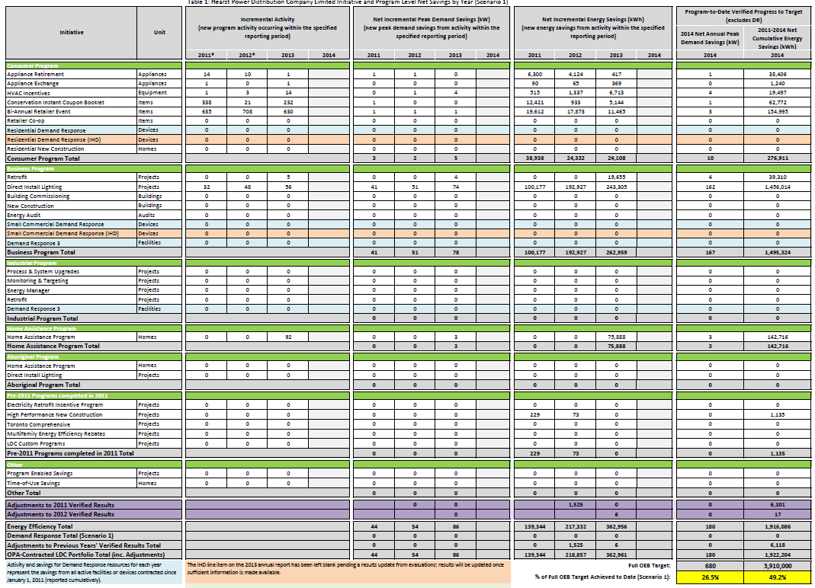
Table 2: Summarized Program Results

Program | Gross Savings |  | Net Savings |  | Contribution to Targets
Program | Incremental Peak Demand Savings (kW) | Incremental Energy Savings (kWh) | Incremental Peak Demand Savings (kW) | Incremental Energy Savings (kWh) | Program-to-Date: Net Annual Peak Demand Savings (kW) in 2014 | Program-to-Date: 2011-2014 Net Cumulative Energy Savings (kWh)
Consumer Program Total | 9 | 31,447 | 5 | 24,108 | 10 | 276,911
Business Program Total | 84 | 285,151 | 78 | 262,959 | 167 | 1,495,324
Industrial Program Total | 0 | 0 | 0 | 0 | 0 | 0
Home Assistance Program Total | 3 | 75,888 | 3 | 75,888 | 3 | 142,716
Pre-2011 Programs completed in 2011 Total | 0 | 0 | 0 | 0 | 0 | 1,135
Adjustments to previous year's verified results | 0 | 11 | 0 | 6 | 0 | 6,118
Total OPA Contracted Province-Wide CDM Programs | 96 | 392,498 | 86 | 362,961 | 180 | 1,922,204

Evaluation 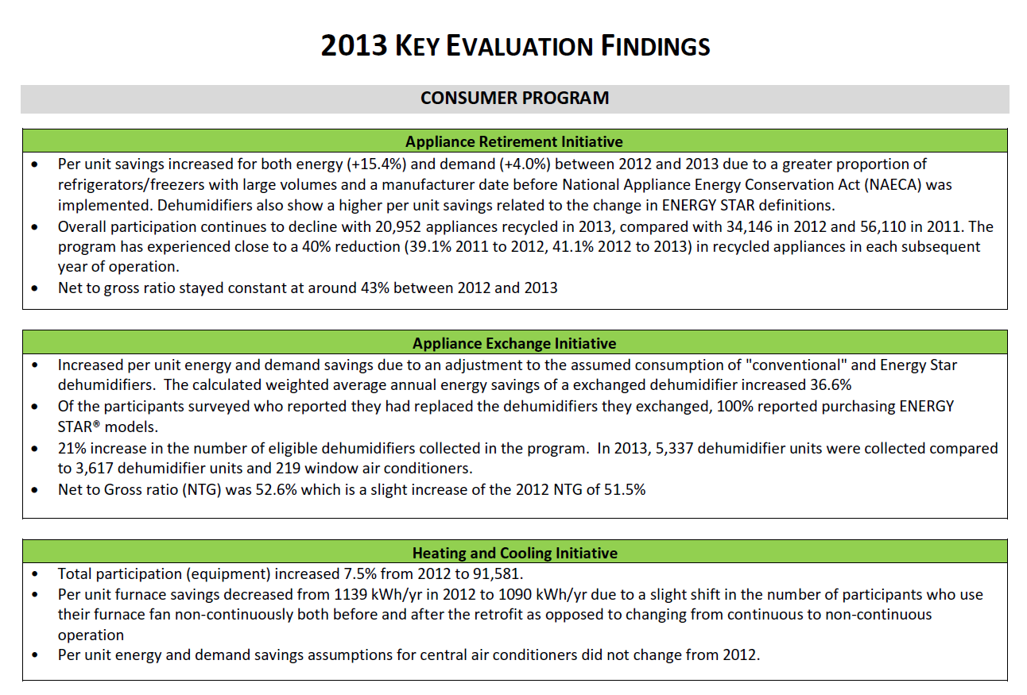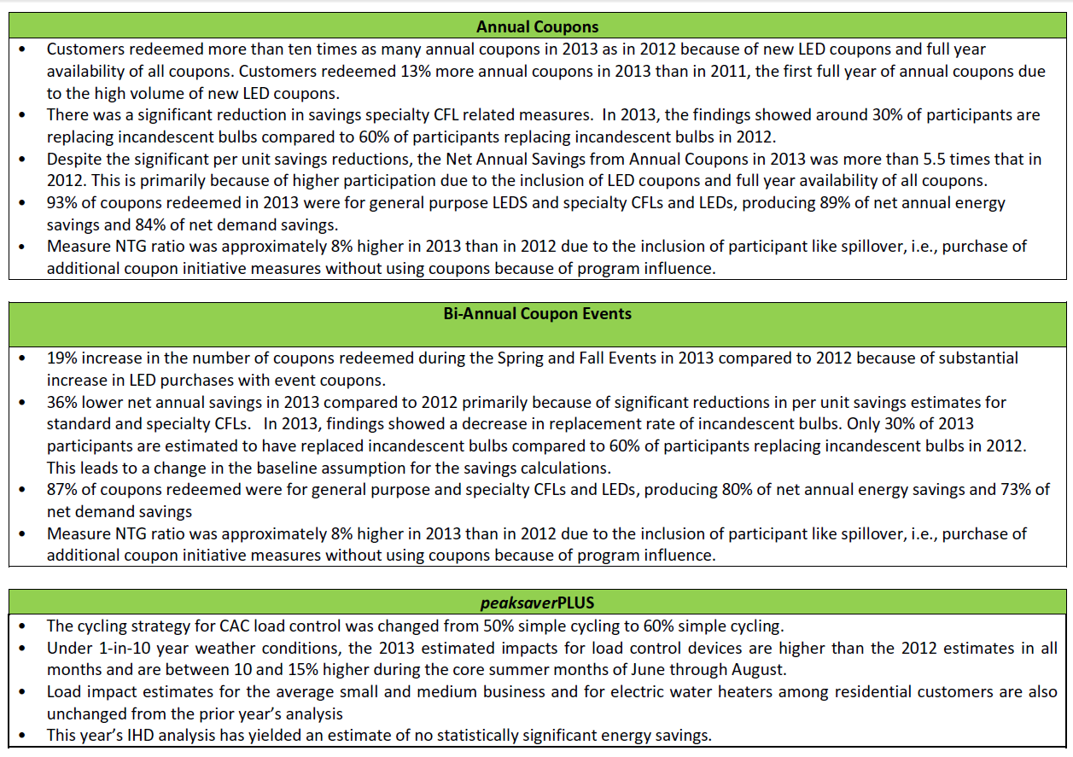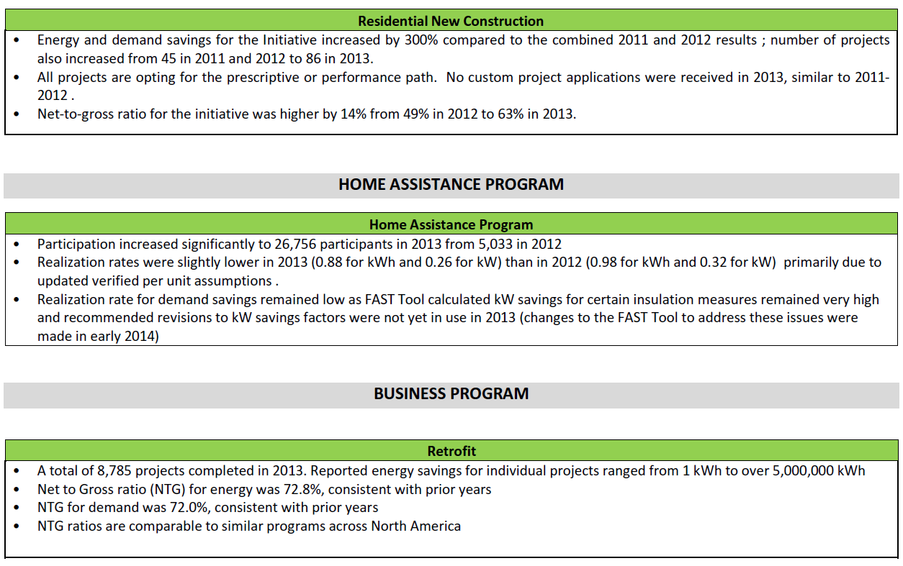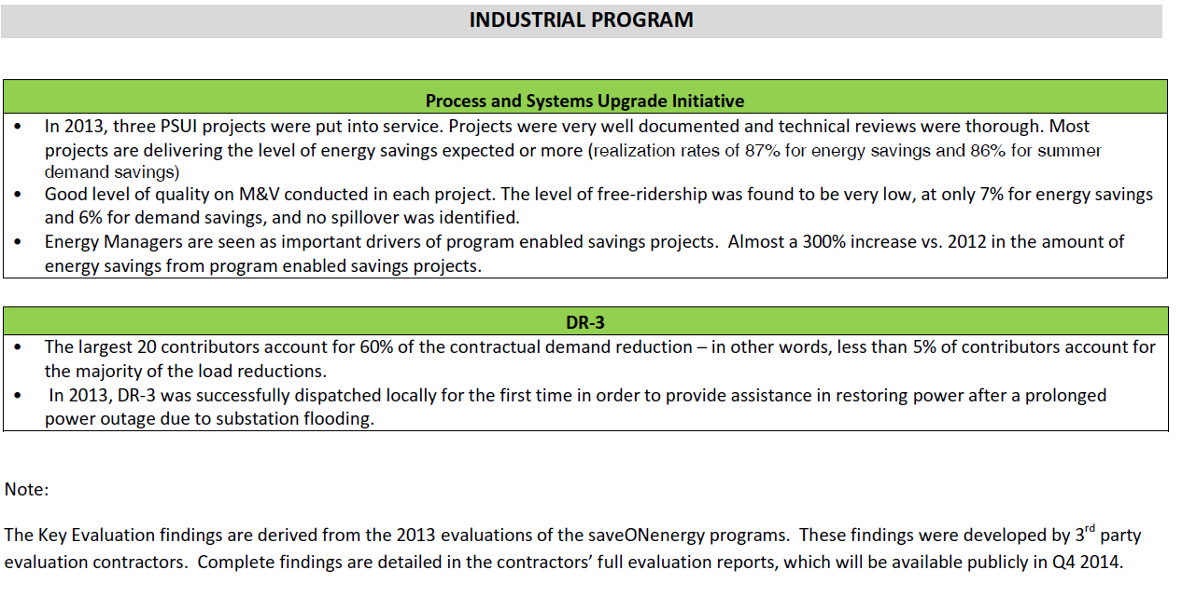

Spending

Table 3 and 4 summarize the total spending by initiative that Hearst Power has incurred in 2013 and cumulatively since 2011. It is detailed by the Program Administration Budget (PAB), Participant Based Funding (PBF), Participant Incentives (PI) and Capability Building Funding (CBF).
Table 3: 2013 Spending –
Initiative | Program Administration Budget (PAB) | Participant Based Funding (PBF) | Participant Incentives (PI) | Capability Building Funding (CBF) | TOTAL
Consumer Program | $ 12,565.54 |  |  |  | $ 12,565.54
Appliance Retirement | $ 1,606.63 |  |  |  | $ 1,606.63
Appliance Exchange | $ 1,606.63 |  |  |  | $ 1,606.63
HVAC Incentives | $ 1,606.63 |  |  |  | $ 1,606.63
Conservation Instant Coupon Booklet | $ 2,840.47 |  |  |  | $ 2,840.47
Bi-Annual Retailer Event | $ 1,606.63 |  |  |  | $ 1,606.63
Retailer Co-op
Residential Demand Response | $ 1,691.92 |  |  |  | $ 1,691.92
New Construction Program | $ 1,606.63 |  |  |  | $ 1,606.63
Business Program | $ 29,850.00 | $ 15,400.00 | $ 89,566.00 |  | $ 134,816.00
Efficiency: Equipment Replacement | $ 7,539.20 |  | $ 765.75 |  | $ 8,304.95
Direct Installed Lighting | $ 15,443.20 | $ 15,400.00 | $ 88,800.25 |  | $ 119,643.45
Existing Building Commissioning Incentive | $ 2,289.20 |  |  |  | $ 2,289.20
New Construction and Major Renovation Initiative | $ 2,289.20 |  |  |  | $ 2,289.20
Energy Audit | $ 2,289.20 |  |  |  | $ 2,289.20
Commercial Demand Response
Demand Response 3
Industrial Program | $ 8,000.00 |  |  |  | $ 8,000.00
Process & System Upgrades
a) preliminary study | $ 1,600.00 |  |  |  | $ 1,600.00
b) engineering study | $ 1,600.00 |  |  |  | $ 1,600.00
c) program incentive
Monitoring & Targeting | $ 1,600.00 |  |  |  | $ 1,600.00
Energy Manager | $ 1,600.00 |  |  |  | $ 1,600.00
Efficiency: Equipment Replacement Incentive
Demand Response 3 | $ 1,600.00 |  |  |  | $ 1,600.00
Low Income | $ 1,855.54 | $ 10,200.00 | $ 5,356.00 |  | $ 17,411.54
TOTAL Province-wide CDM PROGRAMS | $ 52,271.08 | $ 25,600.00 | $ 94,922.00 |  | $ 172,793.08

Table 4: Cumulative Spending (2011-2014)
Initiative | Program Administration Budget (PAB) | Participant Based Funding (PBF) | Participant Incentives (PI) | Capability Building Funding (CBF) | TOTAL
Consumer Program | $ 50,262.10 |  |  |  | $ 50,262.10
Appliance Retirement | $8,434.63 |  |  |  | $ 8,434.63
Appliance Exchange | $7,190.46 |  |  |  | $ 7,190.46
HVAC Incentives | $6,784.55 |  |  |  | $ 6,784.55
Conservation Instant Coupon Booklet | $7,994.80 |  |  |  | $ 7,994.80
Bi-Annual Retailer Event | $6,590.79 |  |  |  | $ 6,590.79
Retailer Co-op
Residential Demand Response | $6,676.09 |  |  |  | $ 6,676.09
New Construction Program | $6,590.80 |  |  |  | $ 6,590.80
Business Program | $ 125,087.32 | $ 37,400.00 | $ 177,716.00 |  | $ 340,203.32
Efficiency: Equipment Replacement | $29,699.21 |  | $ 765.75 |  | $ 30,464.96
Direct Installed Lighting | $39,534.25 | $ 37,400.00 | $176,950.25 |  | $ 253,884.50
Existing Building Commissioning Incentive | $11,526.88 |  |  |  | $ 11,526.88
New Construction and Major Renovation Initiative | $22,163.50 |  |  |  | $ 22,163.50
Energy Audit | $22,163.50 |  |  |  | $ 22,163.50
Commercial Demand Response
Demand Response 3
Industrial Program | $ 34,000.00 |  |  |  | $ 34,000.00
Process & System Upgrades
a) preliminary study | $ 6,000.00 |  |  |  | $ 6,000.00
b) engineering study | $6,000.00 |  |  |  | $ 6,000.00
c) program incentive | $ 4,400.00 |  |  |  | $ 4,400.00
Monitoring & Targeting | $6,000.00 |  |  |  | $ 6,000.00
Energy Manager | $3,600.00 |  |  |  | $ 3,600.00
Efficiency: Equipment Replacement Incentive | $2,000.00 |  |  |  | $ 2,000.00
Demand Response 3 | $6,000.00 |  |  |  | $ 6,000.00
Low Income | $1,855.54 | $ 10,200.00 | $ 5,356.00 |  | $ 17,411.54
TOTAL Province-wide CDM PROGRAMS | $211,204.96 | $ 47,600.00 | $ 183,072.00 |  | $ 441,876.96

Additional Comments

Combined CDM Reporting Elements

Progress Towards CDM Targets

Table 5: Net Peak Demand Savings at the End User Level (MW)
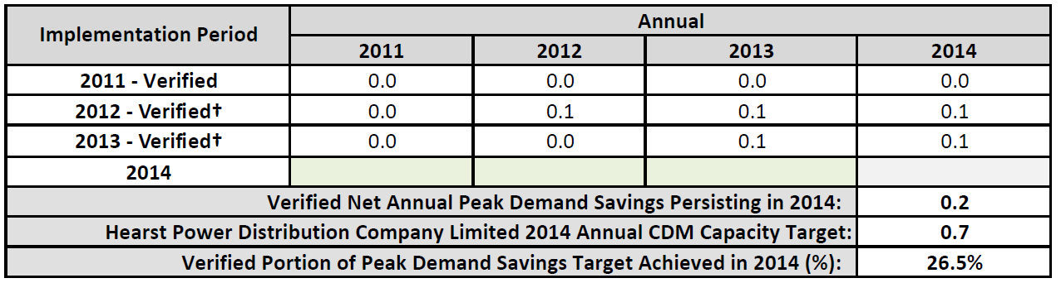
Table 6: Net Energy Savings at the End-User Level (GWh)

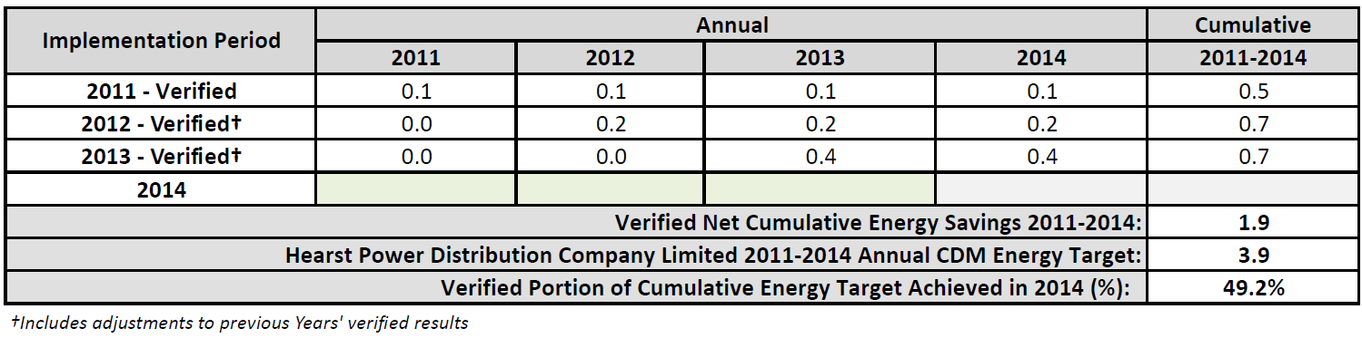

Variance from Strategy

Hearst Power in conjunction with Burman Energy will continue to push local contractors and business towards the saveONenergy programs. Creating buy in for the programs remains one of the main areas of focus. Burman Energy has committed to assisting customers to help identify potential energy savings opportunities, implementing retrofit projects and assisting in the creation and submission of applications for saveONenergy programs. Hearst Power is hopeful that increased awareness of the programs and less ‘paper work’ for the customers and contractors will garner increased participation.

Outlook to 2014 and Strategy Modifications

On March 31st, 2014 the Minister of Energy issued a directive entitled “Continuance of the OPA’s Demand Response Program under IESO management” which effectively halts new customer enrollments in the DR3 program until the IESO has a program in market. This is estimated to be some time in 2015.

The DR3 Initiative is a significant contributor to helping LDCs achieve their demands savings target. The program has taken some time to get traction and LDCs have been diligently working with their customers to encourage participation in the DR3 program. LDC customers are now in a position where many of them have contracted with an Aggregator but will be unable to participate due to the inability of the Aggregator to receive new contract schedules resulting in the current “pipeline” of potential DR contributors being stranded.

Conclusion

Over the course of 2012, Hearst Power has achieved 0.18 MW in peak demand savings and 1.922 GWh in energy savings, which represents 26.5% and 49.2% of Hearst Power 2014 target, respectively. These results are representative of a considerable effort expended by Hearst Power, in cooperation with other LDCs, customers, channel partners and stakeholders to overcome many operational and structural issues that limited program effectiveness across all market sectors. This achievement is a success and the relationships built within the 2011-2014 CDM program term will aid results in a subsequent CDM term.
However, despite continuing improvements to existing programs Hearst Power faces challenges in the remaining years of the current CDM framework. With the current slate of available OPA Programs, and the current forecast of implementation and projected savings, Hearst Power expects a shortage of 1.3 GWh towards consumption target and will struggle to meet its 0.68 MW savings target with a shortage of 0.33 MW.
Looking ahead there is limited opportunity to make valuable changes to the current program portfolios and have these changes reflected in LDC 2014 results. However, LDCs and the OPA can build on the strengths and key successes of the 2011-2014 programs to launch new programs which will meet the needs of the industry and consumers.

Appendix A: Initiative Descriptions

Residential Program

APPLIANCE RETIREMENT INITIATIVE (Exhibit D)

Target Customer Type(s): Residential Customers
Initiative Frequency: Year round
Objectives: Achieve energy and demand savings by permanently decommissioning certain older, inefficient refrigeration appliances.
Description: This is an energy efficiency Initiative that offers individuals and businesses free pick-up and decommissioning of old large refrigerators and freezers. Window air conditioners and portable dehumidifiers will also be picked up if a refrigerator or a freezer is being collected.
Targeted End Uses: Large refrigerators, large freezers, window air conditioners and portable dehumidifiers.
Delivery: OPA centrally contracts for the province-wide marketing, call centre, appliance pick-up and decommissioning process. LDC’s provides local marketing and coordination with municipal pick-up where available.
Additional Detail: Schedule B-1, Exhibit D on the OPA extranet and SaveONenergy website
In Market Date: March 1, 2011

APPLIANCE EXCHANGE INITIATIVE (Exhibit E)

Target Customer Type(s): Residential Customers
Initiative Frequency: Spring and Fall
Objective: The objective of this Initiative is to remove and permanently decommission older, inefficient window air conditioners and portable dehumidifiers that are in Ontario.
Description: This Initiative involves appliance exchange events. Exchange events are held at local retail locations and customers are encouraged to bring in their old room air conditioners (AC) and dehumidifiers in exchange for coupons/discounts towards the purchase of new energy efficient equipment. Window ACs were discontinued from the program in 2013.
Targeted End Uses: Window air conditioners and portable dehumidifiers
Delivery: OPA contracts with participating retailers for collection of eligible units. LDCs provide local marketing.
Additional Detail: Schedule B-1, Exhibit C on the OPA extranet and SaveONenergy website
In Market Date: March 1, 2011
HVAC INCENTIVES INITIATIVE (Exhibit B)

Target Customer Type(s): Residential Customers
Initiative Frequency: Year round
Objective: The objective of this Initiative is to encourage the replacement of existing heating systems with high efficiency furnaces equipped with Electronically Commutated Motors (ECM), and to replace existing central air conditioners with ENERGY STAR qualified systems and products.
Description: This is an energy efficiency Initiative that provides rebates for the replacement of old heating or cooling systems with high efficiency furnaces (equipped with ECM) and ENERGY STAR® qualified central air conditioners by approved Heating, Refrigeration, and Air Conditioning Institute (HRAI) qualified contractors.
Targeted End Uses: Central air conditioners and furnaces
Delivery: OPA contracts centrally for delivery of the program. LDCs provide local marketing and encourage local contractors to participate in the Initiative.
Additional Detail: Schedule B-1, Exhibit B on the OPA extranet and SaveONenergy website
In Market Date: March 1, 2011

CONSERVATION INSTANT COUPON INITIATIVE (Exhibit A)

Target Customer Type(s): Residential Customers
Initiative Frequency: Year round
Objective: The objective of this Initiative is to encourage households to purchase energy efficient products by offering discounts.
Description: This Initiative provides customers with year round coupons. The coupons offer instant rebates towards the purchase of a variety of low cost, easy to install energy efficient measures and can be redeemed at participating retailers. Booklets were directly mailed to customers and were also available at point-of-purchase. Downloadable coupons were also available at www.saveoneenergy.ca.
Targeted End Uses: ENERGY STAR® qualified Standard Compact Flourescent Lights (“CFLs”),ENERGY STAR® qualified Light Fixtures lighting control products, weather-stripping, hot water pipe wrap, electric water heater blanket, heavy duty plug-in Timers, Advanced power bars, clothesline, baseboard programmable thermostats.
Delivery: The OPA develops the electronic version of the coupons and posts them online for download. Three LDC specific coupons were made available for local marketing and utilization by LDCs. The OPA enters into agreements with retailers to honour the coupons.
Additional Detail: Schedule B-1, Exhibit A on the OPA extranet and SaveONenergy website
In Market Date: March 1, 2011

BI-ANNUAL RETAILER EVENT INITIATIVE (Exhibit C)

Target Customer Type(s): Residential Customers
Initiative Frequency: Bi-annual events
Objective: The objective of this Initiative is to provide instant point of purchase discounts to individuals at participating retailers for a variety of energy efficient products.
Description: Twice a year (Spring and Fall), participating retailers host month-long rebate events. During the months of April and October, customers are encouraged to visit participating retailers where they can find coupons redeemable for instant rebates towards a variety of low cost, easy to install energy efficient measures.
Targeted End Uses: As per the Conservation Instant Coupon Initiative
Delivery: The OPA enters into arrangements with participating retailers to promote the discounted products, and to post and honour related coupons. LDCs also refer retailers to the OPA and market this initiative locally.
Additional Detail: Schedule B-1, Exhibit C on the OPA extranet and saveONenergy website
In Market Date: March 2011
In Market Date: March 1, 2011

RETAILER CO-OP

Target Customer Type(s): Residential Customers
Initiative Frequency: Year Round
Objective: Hold promotional events to encourage customers to purchase energy efficiency measures (and go above-and-beyond the traditional Bi-Annual Coupon Events).
Description: The Retailer Co-op Initiative provides LDCs with the opportunity to work with retailers in their service area by holding special events at retail locations. These events are typically special promotions that encourage customers to purchase energy efficiency measures (and go above-and-beyond the traditional Bi-Annual Coupon Events).
Targeted End Uses: As per the Conservation Instant Coupon Initiative
Delivery: Retailers apply to the OPA for co-op funding to run special promotions that promote energy efficiency to customers in their stores. LDCs can refer retailers to the OPA. The OPA provides each LDC with a list of retailers who have qualified for Co-Op Funding as well as details of the proposed special events.
In Market Date: Not in market

NEW CONSTRUCTION PROGRAM (Schedule B-2)

Target Customer Type(s): Residential Customers
Initiative Frequency: Year round
Objective: The objective of this Initiative is to provide incentives to participants for the purpose of promoting the construction of energy efficient residential homes in the Province of Ontario.
Description: This is an energy efficiency Initiative that provides incentives to homebuilders for constructing new homes that are efficient, smart, and integrated (applicable to new single family dwellings). Incentives are provided in two key categories as follows:
  - Incentives for homebuilders who install electricity efficiency measures as determined by a prescriptive list or via a custom option.
  - Incentives for homebuilders who meet or exceed aggressive efficiency standards using the EnerGuide performance rating system.
Targeted End Uses: All off switch, ECM motors, ENERGY STAR® qualified central a/c, lighting control products, lighting fixtures, Energuide 83 whole home, energuide 85 whole homes
Delivery: Local engagement of builders will be the responsibility of the LDC and will be supported by OPA air coverage driving builders to their LDC for additional information.
Additional Detail: Schedule B-1, Exhibit C on the OPA extranet and SaveONenergy website
In Market Date: March 1, 2011

RESIDENTIAL DEMAND RESPONSE PROGRAM (Schedule B-3)

Target Customer Type(s): Residential and Small Commercial Customers
Initiative Frequency: Year round

Objective: The objectives of this Initiative are to enhance the reliability of the IESO-controlled grid by accessing and aggregating specified residential and small commercial end uses for the purpose of load reduction, increasing consumer awareness of the importance of reducing summer demand and providing consumers their current electricity consumption and associated costs.
Description: In peaksaverPLUS ™ participants are eligible to receive a free programmable thermostat or switch, including installation. Participants also receive access to price and real-time consumption information on an In Home Display (IHD).
Targeted End Uses: central air conditioning, electric hot water heaters and pool pumps
Delivery: LDC’s recruit customers and procure technology
Additional Detail: Schedule B-1, Exhibit C on the OPA extranet and SaveONenergy website
In Market Date: Not in market

C&I Program

EFFICIENCY: EQUIPMENT REPLACEMENT INCENTIVE (ERII) (Schedule C-2)

Target Customer Type(s): Commercial, Institutional, Agricultural and Industrial Customers
Initiative Frequency: Year round
Objective: The objective of this Initiative is to offer incentives to non-residential distribution customers to achieve reductions in electricity demand and consumption by upgrading to more energy efficient equipment for lighting, space cooling, ventilation and other measures.
Description: The Equipment Replacement Incentive Initiative (ERII) offers financial incentives to customers for the upgrade of existing equipment to energy efficient equipment. Upgrade projects can be classified into either: 1) prescriptive projects where prescribed measures replace associated required base case equipment; 2) engineered projects where energy and demand savings and incentives are calculated for associated measures; or 3) custom projects for other energy efficiency upgrades.
Targeted End Uses: lighting, space cooling, ventilation and other measures
Delivery: LDC delivered.
Additional Detail: Schedule C-2 on the OPA extranet and saveONenergy website
In Market Date: March 1, 2011
Lessons Learned:

DIRECT INSTALL INITIATIVE (DIL) (Schedule C-3)

Target Customer Type(s): Small Commercial, Institutional, Agricultural facilities and multi-family buildings
Initiative Frequency: Year round
Objective: The objective of this Initiative is to offer a free installation of eligible lighting and water heating measures of up to $1,000 to eligible owners and tenants of small commercial, institutional and agricultural facilities and multi-family buildings, for the purpose of achieving electricity and peak demand savings.
Description: The Direct Installed Lighting Initiative targets customers in the General Service <50kW account category. This Initiative offers turnkey lighting and electric hot water heater measures with a value up to $1,000 at no cost to qualifying small businesses. In addition, standard prescriptive incentives are available for eligible equipment beyond the initial $1,000 limit.
Target End Uses: Lighting and electric water heating measures
Delivery: Participants can enroll directly with the LDC, or would be contacted by the LDC/LDC-designated representative.
Additional Detail: Schedule C-3 on the OPA extranet and SaveONenergy website
Initiative Activities/Progress:
In Market Date: March 1, 2011

EXISTING BUILDING COMMISSIONING INCENTIVE INITIATIVE (Schedule C-6)

Target Customer Type(s): Commercial, Institutional, and Agricultural Customers
Initiative Frequency: Year round
Objective: The objective of this Initiative is to offer incentives for optimizing (but not replacing) existing chilled water systems for space cooling in non-residential facilities for the purpose of achieving implementation phase energy savings, implementation phase demand savings, or both.
Description: This Initiative offers Participants incentives for the following:
- scoping study phase
- investigation phase
- implementation phase
- hand off/completion phase
Targeted End Uses: Chilled water systems for space cooling
Delivery: LDC delivered.
Additional Detail: Schedule C-6 on the OPA extranet and SaveONenergy website Additional detail is available:
Initiative Activities/Progress:
In Market Date: March 1, 2011

NEW CONSTRUCTION AND MAJOR RENOVATION INITIATIVE (HPNC) (Schedule C-4)

Target Customer Type(s): Commercial, Institutional, Agricultural and Industrial Customers
Initiative Frequency: Year round
Objective: The objective of this Initiative is to encourage builders/major renovators of commercial, institutional, and industrial buildings (including multi-family buildings and agricultural facilities) to reduce electricity demand and/or consumption by designing and building new buildings with more energy-efficient equipment and systems for lighting, space cooling, ventilation and other Measures.
Description: The New Construction initiative provides incentives for new buildings to exceed existing codes and standards for energy efficiency. The initiative uses both a prescriptive and custom approach.
Targeted End Uses: New building construction, building modeling, lighting, space cooling, ventilation and other Measures
Delivery: LDC delivers to customers and design decision makers.
Additional Detail: Schedule C-4 on the OPA extranet and SaveONenergy website
Initiative Activities/Progress:
In Market Date: March 1, 2011

ENERGY AUDIT INITIATIVE (Schedule C-1)

Target Customer Type(s): Commercial, Institutional, Agricultural and Industrial Customers
Initiative Frequency: Year round
Objective: The objective of this Initiative is to offer incentives to owners and lessees of commercial, institutional, multi-family buildings and agricultural facilities for the purpose of undertaking assessments to identify all possible opportunities to reduce electricity demand and consumption within their buildings or premises.
Description: This Initiative provides participants incentives for the completion of energy audits of electricity consuming equipment located in the facility. Energy audits include development of energy baselines, use assessments and performance monitoring and reporting.
Targeted End Uses: Various
Delivery: LDC delivered.
Additional Detail: Schedule C-1 on the OPA extranet Schedule C-1 and SaveONenergy website https://saveonenergy.ca/Business/Program-Overviews/Audit-Funding.aspx
Initiative Activities/Progress:
In Market Date: March 1, 2011

Industrial Program

PROCESS & SYSTEMS UPGRADES INITIATIVE (PSUI) (Schedule D-1)

Target Customer Type(s): Industrial, Commercial, Institutional and Agricultural Customers
Initiative Frequency: Year round
Objectives: The objectives of this Initiative are to:
- Offer distribution customers capital incentives and enabling initiatives to assist with the implementation of large projects and project portfolios;
- Implement system optimization project in systems which are intrinsically complex and capital intensive; and
- Increase the capability of distribution customers to implement energy management and system optimization projects.
Description: PSUI is an energy management Initiative that includes three Initiatives: (preliminary engineering study, detailed engineering study, and project incentive Initiative). The incentives are available to large distribution connected customers with projects or portfolio projects that are expected to generate at least 350 MWh of annualized electricity savings or, in the case of Micro-Projects, 100 MWh of annualized electricity savings. The capital incentive for this Initiative is the lowest of:
a) $200/MWh of annualized electricity savings
b) 70% of projects costs
c) A one year pay back
Targeted End Uses: Process and systems
Delivery: LDC delivered with Key Account Management support, in some cases.
Additional Detail: Schedule D-1 on the OPA extranet and saveONenergy website https://saveonenergy.ca/Business.aspx
In Market Date: March 1, 2011

MONITORING & TARGETING INITIATIVE (Schedule D-2)

Target Customer Type(s): Industrial, Commercial, Institutional and Agricultural Customers
Initiative Frequency: Year round
Objective: This Initiative offers access to funding for the installation of Monitoring and Targeting systems in order to deliver a minimum savings target at the end of 24 months and sustained for the term of the M&T Agreement.
Description: This Initiative offers customers funding for the installation of a Monitoring and Targeting system to help them understand how their energy consumption might be reduced. A facility energy manager, who regularly oversees energy usage, will now be able to use historical energy consumption performance to analyze and set targets.
Targeted End Uses: Process and systems
Delivery: LDC delivered with Key Account Management support, in some cases.
Additional Detail: Schedule D-2 on the OPA extranet and saveONenergy website https://saveonenergy.ca/Business.aspx
In Market Date: March 1, 2011

ENERGY MANAGER INITIATIVE (Schedule D-3)

Target Customer Type(s): Industrial, Commercial, Institutional and Agricultural Customers
Initiative Frequency: Year round
Objective: The objective of this initiative is to provide customers and LDCs the opportunity to access funding for the engagement of energy managers in order to deliver a minimum annual savings target.
Description: This Initiative provides customers the opportunity to access funding to engage an on-site, full time embedded energy manager, or an off-site roving energy manager who is engaged by the LDC. The role of the energy manager is to take control of the facility’s energy use by monitoring performance, leading awareness programs, and identifying opportunities for energy consumption improvement, and spearheading projects. Participants are funded 80% of the embedded energy manager’s salary up to $100,000 plus 80% of the energy manager’s actual reasonable expenses incurred up to $8,000 per year. Each embedded energy manager has a target of 300 kW/year of energy savings from one or more facilities. LDCs receive funding of up to $120,000 for a Roving Energy Manager plus $8,000 for expenses.
Targeted End Uses: Process and systems
Delivery: LDC delivered with Key Account Management support, in some cases.
Additional Detail: Schedule D-3 on the OPA extranet and SaveONenergy website https://saveonenergy.ca/Business.aspx
In Market Date: March 1, 2011

KEY ACCOUNT MANAGER (KAM) (Schedule D-4)

Target Customer Type(s): Industrial, Commercial, Institutional and Agricultural Customers
Initiative Frequency: Year round
Objective: This initiative offers LDCs the opportunity to access funding for the employment of a KAM in order to support them in fulfilling their obligations related to the PSUI.
Description: This Initiative provides LDCs the opportunity to utilize a KAM to assist their customers. The KAM is considered to be a key element in assisting the consumer in overcoming traditional barriers related to energy management and help them achieve savings since the KAM can build relationships and become a significant resource of knowledge to the customer.
Targeted End Uses: Process and systems
Delivery: LDC delivered
Additional Detail: ScheduleD-4 on the OPA extranet.
In Market Date: March 1, 2011

DEMAND RESPONSE 3 (Schedule D-6)

Target Customer Type(s): Industrial, Commercial, Institutional and Agricultural Customers
Initiative Frequency: Year round
Objective: This Initiative provides for Demand Response (“DR”) payments to contracted participants to compensate them for reducing their electricity consumption by a pre-defined amount during a DR event.
Description: Demand Response 3 (“DR3”) is a demand response Initiative for commercial and industrial customers, of 50 kW or greater to reduce the amount of power being used during certain periods of the year. The DR3 Initiative is a contractual resource that is an economic alternative to procurement of new generation capacity. DR3 comes with specific contractual obligations requiring participants to reduce their use of electricity relative to a baseline when called upon. This Initiative makes payments for participants to be on standby and payments for the actual electricity reduction provided during a demand response event. Participants are scheduled to be on standby approximately 1,600 hours per calendar year for possible dispatch of up to 100 hours or 200 hours within that year depending on the contract.
Targeted End Uses: Commercial and Industrial Operations
Delivery: DR3 is delivered by Demand Response Providers (“DRPs”), under contract to the OPA. The OPA administers contracts with all DRPs and Direct Participants (who provide in excess of 5 MW of demand response capacity). OPA provides administration including settlement, measurement and verification, and dispatch. LDCs are responsible for local customer outreach and marketing efforts.
Additional Detail: Schedule D-6 available on the OPA and SaveONenergy website https://saveonenergy.ca/Business.aspx
In Market Date: March 1, 2011
It is noted that while the Schedule for this Initiative was not posted until May 2011, the Aggregators reported that they were able to enroll customers as of January 2011.

LOW INCOME INITIATIVE (HOME ASSISTANCE PROGRAM) (Schedule E-1)
Target Customer Type(s): Income Qualified Residential Customers
Initiative Frequency: Year Round
Objective: The objective of this Initiative is to offer free installation of energy efficiency measures to income qualified households for the purpose of achieving electricity and peak demand savings.
Description: This is a turnkey Initiative for income qualified customers. It offers residents the opportunity to take advantage of free installation of energy efficient measures that improve the comfort of their home, increase efficiency, and help them save money. All eligible customers receive a Basic and Extended Measures Audit, while customers with electric heat also receive a Weatherization Audit. The Initiative is designed to coordinate efforts with gas utilities.
Targeted End Uses: End use measures based on results of audit (i.e. compact fluorescent light bulbs)
Delivery: LDC delivered.
Additional Detail: Schedule E available on the OPA extranet.
Initiative Activities/Progress:
BPI took the lead on a group RFP for Home Assistance Program provider in 2011. Due to the delay in schedule release, and the time required for the RFP process, BPI was not in market in 2011, however launched in early 2012.
In Market Date: January 1, 2013

Appendix B: Pre-2011 Programs

ELECTRICITY RETROFIT INCENTIVE PROGRAM
Target Customer Type(s): Commercial, Institutional, and Agricultural Customers
Initiative Frequency: Year Round
Objective: The objective of this Initiative is to offer incentives to non-residential distribution customers to achieve reductions in electricity demand and consumption by upgrading to more energy efficient equipment for lighting, space cooling, ventilation and other measures.
Description: The Equipment Replacement Incentive Program (ERIP) offered financial incentives to customers for the upgrade of existing equipment to energy efficient equipment. This program was available in 2010 and allowed customers up to 11 months following Pre-Approval to complete their projects. As a result, a number of projects Pre-Approved in 2010 were not completed and in-service until 2011. The electricity savings associated with these projects are attributed to 2011.
Targeted End Uses: Electricity savings measures
Delivery: LDC Delivered
HIGH PERFORMANCE NEW CONSTRUCTION
Target Customer Type(s): Commercial, Institutional, and Agricultural Customers
Initiative Frequency: Year round
Objective: The High Performance New Construction Initiative provided incentives for new buildings to exceed existing codes and standards for energy efficiency. The Initiative uses both a prescriptive and custom approach and was delivered by Enbridge Gas under contract with the OPA (and subcontracted to Union Gas), which ran until December 2010.
Description: The objective of this Initiative is to encourage builders of commercial, institutional, and industrial buildings (including multi-family buildings and agricultural facilities) to reduce electricity demand and/or consumption by designing and building new buildings with more energy-efficient equipment and systems for lighting, space cooling, ventilation and other Measures.
Targeted End Uses: New Building construction, building modeling, lighting, space cooling, ventilation and other measures
Delivery: Through Enbridge Gas (and subcontracted to Union Gas)

