2730 Highway #3, Telephone (519) 737-9811
Oldcastle, ON N0R 1L0 Fax (519) 737-7064



August 16, 2013

Ms. Kirsten Walli, Board Secretary
Ontario Energy Board
2300 Yonge Street, 26th Floor, P.O. Box 2319
Toronto, ON M4P 1E4

Re: Essex Powerlines Corporation 2014 Incentive Regulation Mechanism (IRM) Application Tranche Change Request

Dear Ms. Walli:

Essex Powerlines Corporation (Essex) is scheduled to file its 2014 Incentive Regulation Mechanism (IRM) rate application for rates effective May 1, 2014 as a tranche 1 filer with a due date of August 30, 2013 as noted in the Board’s letter dated August 16, 2013. Essex respectively requests a change to tranche 3 with a due date of September 27, 2013. Essex has considerable work yet to be completed for its application and due to staff limitations at this time of the year, we require additional time for Essex to submit its IRM application.

We appreciate the Board’s indulgence for our request for additional time.

Sincerely,

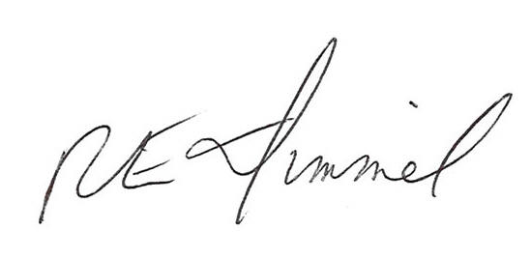

Richard Dimmel, CMA
General Manager
rdimmel@essexpowerlines.ca

